МИНИСТЕРСТВО ОБРАЗОВАНИЯ

И НАУКИ РОССИЙСКОЙ ФЕДЕРАЦИИ

ФЕДЕРАЛЬНОЕ ГОСУДАРСТВЕННОЕ АВТОНОМНОЕ ОБРАЗОВАТЕЛЬНОЕ УЧРЕЖДЕНИЕ

ВЫСШЕГО ПРОФЕССИОНАЛЬНОГО ОБРАЗОВАНИЯ

«ЮЖНЫЙ ФЕДЕРАЛЬНЫЙ УНИВЕРСИТЕТ»

ИНЖЕНЕРНО-ТЕХНОЛОГИЧЕСКАЯ АКАДЕМИЯ

Институт компьютерных технологий и информационной безопасности

Кафедра математического обеспечения и применения ЭВМ

Лабораторная работа № 6

по курсу «Объектно-ориентированное программирование»

«Создание графического интерфейса в С#»

13 ВАРИАНТ

Выполнили:

студенты гр. КТбо2-6

Шевченко А. В.

Проверил:

Быстров Э. А.

Таганрог 2020

**Цель работы:** Ознакомление с основами создание графического интерфейса в С#.

1. Вариант задания №13

Разработать графический интерфейс пользователя для программы из 5 лабораторной работы.

1. Спецификация классов с комментариями.

Был написан базовый Human с полем для хранения пароля и свойством для логина, метод хеширования и метод проверяющий совпадения с паролем введённой строки с полем. Так же были перегружены сравнения. На основе это класса были разработаны два класса Admin и Client. Первый ничего не привносит, позволяя “создать” класс типа Human. Класс Client имеет свойства полное имя, пол, день рождения, возраст, город проживания, номер телефона, проверяемые с помощью статических методов класса StandartView. Поля класса Client полное имя, пол, знак зодиака и число, полученное комбинаторикой имени. Для получения данных клиента был разработан класс Result с соответствующими полями который используется в классе User который делает запрос на интернет-ресурсе и создаёт класс Result из которого извлекается массив строк. Класс DataBese имеет три приватных поля хранящих администраторов и клиентов, не сортированных и сортированных по городам и полу. Так же методы возвращающий лист клиентов, подходящих пользователю. Так же был разработан класс взаимодействующий с клиентом и админом.

1. Диаграмма классов

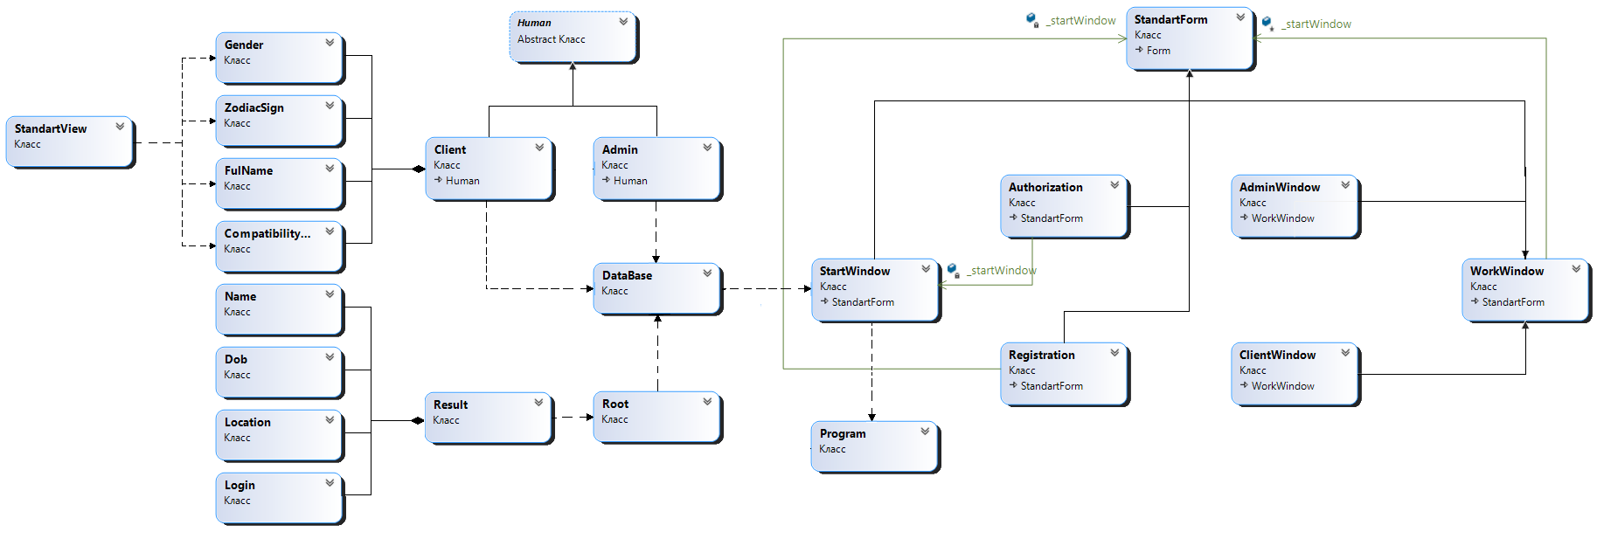

Рисунок 1 – диаграмма классов

1. Листинг программы

Program.cs:

static class Program

{

/// <summary>

/// The main entry point for the application.

/// </summary>

[STAThread]

static void Main()

{

var database = new Database();

database.GenerateCityInDataBase(100,"Таганрог");

Application.SetHighDpiMode(HighDpiMode.SystemAware);

Application.EnableVisualStyles();

Application.SetCompatibleTextRenderingDefault(false);

Application.Run(new StartWindow(database));

}

}

StandartForm:

using System.Windows.Forms;

namespace laba6

{

internal class StandartForm : Form

{

private Panel panel1;

private Label label1;

private Label label2;

private Label programName;

public StandartForm()

{

InitializeComponent();

this.FormClosing += new FormClosingEventHandler(Form1_FormClosing);

}

protected void Form1_FormClosing(object sender, FormClosingEventArgs e)

{

if (e.CloseReason == CloseReason.UserClosing)

{

Application.Exit();

}

}

private void InitializeComponent()

{

System.ComponentModel.ComponentResourceManager resources = new System.ComponentModel.ComponentResourceManager(typeof(StandartForm));

this.panel1 = new System.Windows.Forms.Panel();

this.label1 = new System.Windows.Forms.Label();

this.programName = new System.Windows.Forms.Label();

this.label2 = new System.Windows.Forms.Label();

this.panel1.SuspendLayout();

this.SuspendLayout();

//

// panel1

//

this.panel1.BackColor = System.Drawing.Color.Fuchsia;

this.panel1.Controls.Add(this.label1);

this.panel1.Controls.Add(this.programName);

this.panel1.Dock = System.Windows.Forms.DockStyle.Top;

this.panel1.Location = new System.Drawing.Point(0, 0);

this.panel1.Name = "panel1";

this.panel1.Size = new System.Drawing.Size(411, 82);

this.panel1.TabIndex = 0;

//

// label1

//

this.label1.AutoSize = true;

this.label1.Font = new System.Drawing.Font("Arial Narrow", 14.25F, ((System.Drawing.FontStyle)((System.Drawing.FontStyle.Bold | System.Drawing.FontStyle.Italic))), System.Drawing.GraphicsUnit.Point);

this.label1.ForeColor = System.Drawing.SystemColors.ButtonFace;

this.label1.Location = new System.Drawing.Point(15, 46);

this.label1.Name = "label1";

this.label1.Size = new System.Drawing.Size(189, 23);

this.label1.TabIndex = 1;

this.label1.Text = "стопроцентный брак";

//

// programName

//

this.programName.AutoSize = true;

this.programName.Font = new System.Drawing.Font("Arial Narrow", 30F, ((System.Drawing.FontStyle)((System.Drawing.FontStyle.Bold | System.Drawing.FontStyle.Italic))), System.Drawing.GraphicsUnit.Point);

this.programName.ForeColor = System.Drawing.SystemColors.ButtonHighlight;

this.programName.Location = new System.Drawing.Point(12, 9);

this.programName.Name = "programName";

this.programName.Size = new System.Drawing.Size(144, 46);

this.programName.TabIndex = 0;

this.programName.Text = "ШНЯГА";

//

// label2

//

this.label2.AutoSize = true;

this.label2.Dock = System.Windows.Forms.DockStyle.Bottom;

this.label2.Location = new System.Drawing.Point(0, 430);

this.label2.Name = "label2";

this.label2.Size = new System.Drawing.Size(134, 19);

this.label2.TabIndex = 1;

this.label2.Text = "Created by AlexShev";

//

// StandartForm

//

this.BackColor = System.Drawing.SystemColors.ActiveBorder;

this.ClientSize = new System.Drawing.Size(411, 449);

this.Controls.Add(this.label2);

this.Controls.Add(this.panel1);

this.Icon = ((System.Drawing.Icon)(resources.GetObject("$this.Icon")));

this.Name = "StandartForm";

this.Text = "Шняга";

this.panel1.ResumeLayout(false);

this.panel1.PerformLayout();

this.ResumeLayout(false);

this.PerformLayout();

}

// для будующих окон

protected void SetTextBox(TextBox textBox, string parametr)

{

if (textBox.Text == parametr)

{

textBox.Text = string.Empty;

textBox.ForeColor = System.Drawing.Color.Black;

textBox.BackColor = System.Drawing.Color.White;

}

}

protected void CorrectTextBox(TextBox textBox, string parametr)

{

if (textBox.Text == string.Empty)

{

textBox.Text = parametr;

textBox.ForeColor = System.Drawing.Color.Gray;

textBox.BackColor = System.Drawing.Color.White;

}

}

}

}

StartWindow.cs:

using System;

using System.Windows.Forms;

namespace laba6

{

class StartWindow : StandartForm

{

private Panel panel2;

private Button buttonAdmin;

private Button buttonNewClient;

private Label label3;

private Button buttonClient;

private Button exit;

// не придумал как иначе, не нравиться

private readonly Database _database;

public StartWindow(Database database)

{

_database = database;

InitializeComponent();

}

private void InitializeComponent()

{

this.panel2 = new System.Windows.Forms.Panel();

this.exit = new System.Windows.Forms.Button();

this.label3 = new System.Windows.Forms.Label();

this.buttonAdmin = new System.Windows.Forms.Button();

this.buttonNewClient = new System.Windows.Forms.Button();

this.buttonClient = new System.Windows.Forms.Button();

this.panel2.SuspendLayout();

this.SuspendLayout();

//

// panel2

//

this.panel2.Anchor = System.Windows.Forms.AnchorStyles.None;

this.panel2.BackColor = System.Drawing.Color.Fuchsia;

this.panel2.BorderStyle = System.Windows.Forms.BorderStyle.FixedSingle;

this.panel2.Controls.Add(this.exit);

this.panel2.Controls.Add(this.label3);

this.panel2.Controls.Add(this.buttonAdmin);

this.panel2.Controls.Add(this.buttonNewClient);

this.panel2.Controls.Add(this.buttonClient);

this.panel2.Location = new System.Drawing.Point(57, 119);

this.panel2.Name = "panel2";

this.panel2.Size = new System.Drawing.Size(319, 357);

this.panel2.TabIndex = 2;

//

// exit

//

this.exit.Anchor = System.Windows.Forms.AnchorStyles.None;

this.exit.BackColor = System.Drawing.SystemColors.ButtonFace;

this.exit.Cursor = System.Windows.Forms.Cursors.Hand;

this.exit.FlatAppearance.MouseDownBackColor = System.Drawing.Color.Silver;

this.exit.FlatAppearance.MouseOverBackColor = System.Drawing.Color.FromArgb(((int)(((byte)(224)))), ((int)(((byte)(224)))), ((int)(((byte)(224)))));

this.exit.FlatStyle = System.Windows.Forms.FlatStyle.Flat;

this.exit.Font = new System.Drawing.Font("Arial", 9.75F, System.Drawing.FontStyle.Regular, System.Drawing.GraphicsUnit.Point);

this.exit.Location = new System.Drawing.Point(121, 316);

this.exit.Name = "exit";

this.exit.Size = new System.Drawing.Size(74, 24);

this.exit.TabIndex = 14;

this.exit.Text = "выйти";

this.exit.UseVisualStyleBackColor = false;

this.exit.Click += new System.EventHandler(this.Exit_Click);

//

// label3

//

this.label3.AutoSize = true;

this.label3.Font = new System.Drawing.Font("Arial Narrow", 21.75F, System.Drawing.FontStyle.Bold, System.Drawing.GraphicsUnit.Point);

this.label3.Location = new System.Drawing.Point(35, 29);

this.label3.Name = "label3";

this.label3.Size = new System.Drawing.Size(252, 33);

this.label3.TabIndex = 8;

this.label3.Text = "Выберете действие";

//

// buttonAdmin

//

this.buttonAdmin.Anchor = System.Windows.Forms.AnchorStyles.None;

this.buttonAdmin.BackColor = System.Drawing.SystemColors.ButtonFace;

this.buttonAdmin.Cursor = System.Windows.Forms.Cursors.Hand;

this.buttonAdmin.FlatAppearance.MouseDownBackColor = System.Drawing.Color.Silver;

this.buttonAdmin.FlatAppearance.MouseOverBackColor = System.Drawing.Color.FromArgb(((int)(((byte)(224)))), ((int)(((byte)(224)))), ((int)(((byte)(224)))));

this.buttonAdmin.FlatStyle = System.Windows.Forms.FlatStyle.Flat;

this.buttonAdmin.Font = new System.Drawing.Font("Arial", 17.25F, System.Drawing.FontStyle.Regular, System.Drawing.GraphicsUnit.Point);

this.buttonAdmin.Location = new System.Drawing.Point(26, 244);

this.buttonAdmin.Name = "buttonAdmin";

this.buttonAdmin.Size = new System.Drawing.Size(265, 47);

this.buttonAdmin.TabIndex = 7;

this.buttonAdmin.Text = "Для администраторов";

this.buttonAdmin.UseVisualStyleBackColor = false;

this.buttonAdmin.Click += new System.EventHandler(this.ButtonAdmin_Click);

//

// buttonNewClient

//

this.buttonNewClient.Anchor = System.Windows.Forms.AnchorStyles.None;

this.buttonNewClient.BackColor = System.Drawing.SystemColors.ButtonFace;

this.buttonNewClient.Cursor = System.Windows.Forms.Cursors.Hand;

this.buttonNewClient.FlatAppearance.MouseDownBackColor = System.Drawing.Color.Silver;

this.buttonNewClient.FlatAppearance.MouseOverBackColor = System.Drawing.Color.FromArgb(((int)(((byte)(224)))), ((int)(((byte)(224)))), ((int)(((byte)(224)))));

this.buttonNewClient.FlatStyle = System.Windows.Forms.FlatStyle.Flat;

this.buttonNewClient.Font = new System.Drawing.Font("Arial", 17.25F, System.Drawing.FontStyle.Regular, System.Drawing.GraphicsUnit.Point);

this.buttonNewClient.Location = new System.Drawing.Point(26, 175);

this.buttonNewClient.Name = "buttonNewClient";

this.buttonNewClient.Size = new System.Drawing.Size(265, 47);

this.buttonNewClient.TabIndex = 6;

this.buttonNewClient.Text = "Зарегестрироватья";

this.buttonNewClient.UseVisualStyleBackColor = false;

this.buttonNewClient.Click += new System.EventHandler(this.buttonNewClient_Click);

//

// buttonClient

//

this.buttonClient.Anchor = System.Windows.Forms.AnchorStyles.None;

this.buttonClient.BackColor = System.Drawing.SystemColors.ButtonFace;

this.buttonClient.Cursor = System.Windows.Forms.Cursors.Hand;

this.buttonClient.FlatAppearance.MouseDownBackColor = System.Drawing.Color.Silver;

this.buttonClient.FlatAppearance.MouseOverBackColor = System.Drawing.Color.FromArgb(((int)(((byte)(224)))), ((int)(((byte)(224)))), ((int)(((byte)(224)))));

this.buttonClient.FlatStyle = System.Windows.Forms.FlatStyle.Flat;

this.buttonClient.Font = new System.Drawing.Font("Arial", 18F, System.Drawing.FontStyle.Regular, System.Drawing.GraphicsUnit.Point);

this.buttonClient.Location = new System.Drawing.Point(26, 105);

this.buttonClient.Name = "buttonClient";

this.buttonClient.Size = new System.Drawing.Size(265, 47);

this.buttonClient.TabIndex = 5;

this.buttonClient.Text = "Войти";

this.buttonClient.UseVisualStyleBackColor = false;

this.buttonClient.Click += new System.EventHandler(this.ButtonClient_Click);

//

// StartWindow

//

this.ClientSize = new System.Drawing.Size(434, 519);

this.Controls.Add(this.panel2);

this.Name = "StartWindow";

this.WindowState = System.Windows.Forms.FormWindowState.Maximized;

this.Controls.SetChildIndex(this.panel2, 0);

this.panel2.ResumeLayout(false);

this.panel2.PerformLayout();

this.ResumeLayout(false);

this.PerformLayout();

}

private void ButtonClient_Click(object sender, EventArgs e)

{

this.Hide();

Authorization authorization = new Authorization(this, _database, false);

authorization.Show();

}

private void ButtonAdmin_Click(object sender, EventArgs e)

{

this.Hide();

Authorization authorization = new Authorization(this, _database, true);

authorization.Show();

}

private void buttonNewClient_Click(object sender, EventArgs e)

{

this.Hide();

Registration registration = new Registration(this, _database);

registration.Show();

}

private void Exit_Click(object sender, EventArgs e)

{

Application.Exit();

}

}

}

Authorization.cs:

using System;

using System.Drawing;

using System.Windows.Forms;

namespace laba6

{

class Authorization : StandartForm

{

private Panel panel2;

private Label label3;

private TextBox password;

private TextBox login;

private PictureBox pictureBox2;

private PictureBox pictureBox1;

private Button buttonClient;

private readonly Database _database;

private readonly bool _isAdmin;

private readonly string enterLogin = "Введите логин";

private Button predicant;

private readonly string enterPassword = "Введите пароль";

private readonly StartWindow _startWindow;

public Authorization(StartWindow startWindow, Database database, bool isAdmin = false)

{

_startWindow = startWindow;

_database = database;

_isAdmin = isAdmin;

InitializeComponent();

CorrectTextBox(login, enterLogin);

CorrectTextBox(password, enterPassword);

}

private void InitializeComponent()

{

System.ComponentModel.ComponentResourceManager resources = new System.ComponentModel.ComponentResourceManager(typeof(Authorization));

this.panel2 = new System.Windows.Forms.Panel();

this.predicant = new System.Windows.Forms.Button();

this.pictureBox2 = new System.Windows.Forms.PictureBox();

this.pictureBox1 = new System.Windows.Forms.PictureBox();

this.password = new System.Windows.Forms.TextBox();

this.login = new System.Windows.Forms.TextBox();

this.label3 = new System.Windows.Forms.Label();

this.buttonClient = new System.Windows.Forms.Button();

this.panel2.SuspendLayout();

((System.ComponentModel.ISupportInitialize)(this.pictureBox2)).BeginInit();

((System.ComponentModel.ISupportInitialize)(this.pictureBox1)).BeginInit();

this.SuspendLayout();

//

// panel2

//

this.panel2.Anchor = System.Windows.Forms.AnchorStyles.None;

this.panel2.BackColor = System.Drawing.Color.Fuchsia;

this.panel2.BorderStyle = System.Windows.Forms.BorderStyle.FixedSingle;

this.panel2.Controls.Add(this.predicant);

this.panel2.Controls.Add(this.pictureBox2);

this.panel2.Controls.Add(this.pictureBox1);

this.panel2.Controls.Add(this.password);

this.panel2.Controls.Add(this.login);

this.panel2.Controls.Add(this.label3);

this.panel2.Controls.Add(this.buttonClient);

this.panel2.Location = new System.Drawing.Point(57, 119);

this.panel2.Name = "panel2";

this.panel2.Size = new System.Drawing.Size(319, 357);

this.panel2.TabIndex = 2;

//

// predicant

//

this.predicant.Anchor = System.Windows.Forms.AnchorStyles.None;

this.predicant.BackColor = System.Drawing.SystemColors.ButtonFace;

this.predicant.Cursor = System.Windows.Forms.Cursors.Hand;

this.predicant.FlatAppearance.MouseDownBackColor = System.Drawing.Color.Silver;

this.predicant.FlatAppearance.MouseOverBackColor = System.Drawing.Color.FromArgb(((int)(((byte)(224)))), ((int)(((byte)(224)))), ((int)(((byte)(224)))));

this.predicant.FlatStyle = System.Windows.Forms.FlatStyle.Flat;

this.predicant.Font = new System.Drawing.Font("Arial", 9.75F, System.Drawing.FontStyle.Regular, System.Drawing.GraphicsUnit.Point);

this.predicant.Location = new System.Drawing.Point(122, 309);

this.predicant.Name = "predicant";

this.predicant.Size = new System.Drawing.Size(74, 24);

this.predicant.TabIndex = 13;

this.predicant.Text = "назад";

this.predicant.UseVisualStyleBackColor = false;

this.predicant.Click += new System.EventHandler(this.predicant_Click);

//

// pictureBox2

//

this.pictureBox2.Image = ((System.Drawing.Image)(resources.GetObject("pictureBox2.Image")));

this.pictureBox2.Location = new System.Drawing.Point(33, 171);

this.pictureBox2.Name = "pictureBox2";

this.pictureBox2.Size = new System.Drawing.Size(43, 35);

this.pictureBox2.SizeMode = System.Windows.Forms.PictureBoxSizeMode.Zoom;

this.pictureBox2.TabIndex = 12;

this.pictureBox2.TabStop = false;

//

// pictureBox1

//

this.pictureBox1.Image = ((System.Drawing.Image)(resources.GetObject("pictureBox1.Image")));

this.pictureBox1.Location = new System.Drawing.Point(33, 93);

this.pictureBox1.Name = "pictureBox1";

this.pictureBox1.Size = new System.Drawing.Size(42, 49);

this.pictureBox1.SizeMode = System.Windows.Forms.PictureBoxSizeMode.Zoom;

this.pictureBox1.TabIndex = 11;

this.pictureBox1.TabStop = false;

//

// password

//

this.password.Font = new System.Drawing.Font("Arial", 18F, System.Drawing.FontStyle.Regular, System.Drawing.GraphicsUnit.Point);

this.password.Location = new System.Drawing.Point(74, 170);

this.password.Name = "password";

this.password.Size = new System.Drawing.Size(213, 35);

this.password.TabIndex = 10;

this.password.Enter += new System.EventHandler(this.Password_Enter);

this.password.Leave += new System.EventHandler(this.Password_Leave);

//

// login

//

this.login.Font = new System.Drawing.Font("Arial", 18F, System.Drawing.FontStyle.Regular, System.Drawing.GraphicsUnit.Point);

this.login.Location = new System.Drawing.Point(74, 99);

this.login.Name = "login";

this.login.Size = new System.Drawing.Size(213, 35);

this.login.TabIndex = 9;

this.login.Enter += new System.EventHandler(this.Login_Enter);

this.login.Leave += new System.EventHandler(this.Login_Leave);

//

// label3

//

this.label3.AutoSize = true;

this.label3.FlatStyle = System.Windows.Forms.FlatStyle.Flat;

this.label3.Font = new System.Drawing.Font("Arial Black", 24F, System.Drawing.FontStyle.Bold, System.Drawing.GraphicsUnit.Point);

this.label3.ForeColor = System.Drawing.Color.White;

this.label3.Location = new System.Drawing.Point(33, 24);

this.label3.Name = "label3";

this.label3.Size = new System.Drawing.Size(254, 45);

this.label3.TabIndex = 8;

this.label3.Text = "Авторизация";

this.label3.TextAlign = System.Drawing.ContentAlignment.TopCenter;

//

// buttonClient

//

this.buttonClient.Anchor = System.Windows.Forms.AnchorStyles.None;

this.buttonClient.BackColor = System.Drawing.SystemColors.ButtonFace;

this.buttonClient.Cursor = System.Windows.Forms.Cursors.Hand;

this.buttonClient.FlatAppearance.MouseDownBackColor = System.Drawing.Color.Silver;

this.buttonClient.FlatAppearance.MouseOverBackColor = System.Drawing.Color.FromArgb(((int)(((byte)(224)))), ((int)(((byte)(224)))), ((int)(((byte)(224)))));

this.buttonClient.FlatStyle = System.Windows.Forms.FlatStyle.Flat;

this.buttonClient.Font = new System.Drawing.Font("Arial", 18F, System.Drawing.FontStyle.Regular, System.Drawing.GraphicsUnit.Point);

this.buttonClient.Location = new System.Drawing.Point(84, 241);

this.buttonClient.Name = "buttonClient";

this.buttonClient.Size = new System.Drawing.Size(148, 47);

this.buttonClient.TabIndex = 5;

this.buttonClient.Text = "Войти";

this.buttonClient.UseVisualStyleBackColor = false;

this.buttonClient.Click += new System.EventHandler(this.ButtonEnter_Click);

//

// Authorization

//

this.ClientSize = new System.Drawing.Size(434, 519);

this.Controls.Add(this.panel2);

this.Name = "Authorization";

this.WindowState = System.Windows.Forms.FormWindowState.Maximized;

this.Controls.SetChildIndex(this.panel2, 0);

this.panel2.ResumeLayout(false);

this.panel2.PerformLayout();

((System.ComponentModel.ISupportInitialize)(this.pictureBox2)).EndInit();

((System.ComponentModel.ISupportInitialize)(this.pictureBox1)).EndInit();

this.ResumeLayout(false);

this.PerformLayout();

}

private void Login_Enter(object sender, EventArgs e)

{

login.BackColor = Color.White;

SetTextBox(login, enterLogin);

}

private void Login_Leave(object sender, EventArgs e)

{

CorrectTextBox(login, enterLogin);

if (login.Text == enterLogin ||

(_isAdmin) ? _database.IsFreeLoginAdmins(login.Text) : _database.IsFreeLoginClients(login.Text))

{

login.BackColor = Color.Red;

}

}

private void Password_Enter(object sender, EventArgs e)

{

password.BackColor = Color.White;

SetTextBox(password, enterPassword);

password.UseSystemPasswordChar = true;

}

private void Password_Leave(object sender, EventArgs e)

{

CorrectTextBox(password, enterPassword);

if (password.Text == enterPassword)

{

password.UseSystemPasswordChar = false;

password.BackColor = Color.Red;

}

else if (!IsMyHuman())

{

password.BackColor = Color.Red;

}

}

private bool IsMyHuman()

{

try

{

return (_isAdmin) ? _database.IsMyAdmin(new Admin(login.Text, password.Text)) : _database.IsMyClient(login.Text, password.Text);

}

catch (Exception)

{

return false;

}

}

private void ButtonEnter_Click(object sender, EventArgs e)

{

if (IsMyHuman())

{

this.Hide();

if (_isAdmin)

{

var adminWindow = new AdminWindow(_startWindow, _database, login.Text, password.Text);

adminWindow.Show();

}

else

{

var clientWindow = new ClientWindow(_startWindow, _database, login.Text, password.Text);

clientWindow.Show();

}

}

else

{

MessageBox.Show("Ошибка ввода!!!\nОбратите внимание на красные поля");

}

}

private void predicant_Click(object sender, EventArgs e)

{

_startWindow.Show();

this.Hide();

}

}

}

Registration.cs:

using System;

using System.Drawing;

using System.Windows.Forms;

namespace laba6

{

class Registration : StandartForm

{

private Panel panel2;

private Label label3;

private TextBox password;

private TextBox login;

private PictureBox pictureBox2;

private Button buttonClient;

private readonly Database _database;

private readonly string enterLogin = "Введите логин";

private readonly string enterPassword = "Введите пароль";

private readonly string enterLastName = "Введите фамилию";

private readonly string enterFirstName = "Введите имя";

private readonly string enterCity = "Введите город";

private Button predicant;

private PictureBox pictureBox1;

private MaskedTextBox PhoneNumber;

private DateTimePicker Birthday;

private TextBox LastName;

private TextBox City;

private Label Sex;

private CheckBox femal;

private CheckBox masculine;

private TextBox FirstName;

private Panel ErrorDate;

private readonly StandartForm _startWindow;

private readonly bool _isNewAdmin;

private readonly bool _isStartWindow;

public Registration(StandartForm startWindow, Database database, bool IsNewAdmin = false, bool isStartWindow = false)

{

_startWindow = startWindow;

_database = database;

_isNewAdmin = IsNewAdmin;

_isStartWindow = isStartWindow;

if (IsNewAdmin)

{

InitializeComponentForAdmin();

}

else

{

InitializeComponent();

CorrectTextBox(LastName, enterLastName);

CorrectTextBox(FirstName, enterFirstName);

CorrectTextBox(City, enterCity);

}

CorrectTextBox(login, enterLogin);

CorrectTextBox(password, enterPassword);

}

private void InitializeComponentForAdmin()

{

System.ComponentModel.ComponentResourceManager resources = new System.ComponentModel.ComponentResourceManager(typeof(Registration));

this.panel2 = new System.Windows.Forms.Panel();

this.predicant = new System.Windows.Forms.Button();

this.pictureBox2 = new System.Windows.Forms.PictureBox();

this.pictureBox1 = new System.Windows.Forms.PictureBox();

this.password = new System.Windows.Forms.TextBox();

this.login = new System.Windows.Forms.TextBox();

this.label3 = new System.Windows.Forms.Label();

this.buttonClient = new System.Windows.Forms.Button();

this.panel2.SuspendLayout();

((System.ComponentModel.ISupportInitialize)(this.pictureBox2)).BeginInit();

((System.ComponentModel.ISupportInitialize)(this.pictureBox1)).BeginInit();

this.SuspendLayout();

//

// panel2

//

this.panel2.Anchor = System.Windows.Forms.AnchorStyles.None;

this.panel2.BackColor = System.Drawing.Color.Fuchsia;

this.panel2.BorderStyle = System.Windows.Forms.BorderStyle.FixedSingle;

this.panel2.Controls.Add(this.predicant);

this.panel2.Controls.Add(this.pictureBox2);

this.panel2.Controls.Add(this.pictureBox1);

this.panel2.Controls.Add(this.password);

this.panel2.Controls.Add(this.login);

this.panel2.Controls.Add(this.label3);

this.panel2.Controls.Add(this.buttonClient);

this.panel2.Location = new System.Drawing.Point(57, 119);

this.panel2.Name = "panel2";

this.panel2.Size = new System.Drawing.Size(319, 357);

this.panel2.TabIndex = 2;

//

// predicant

//

this.predicant.Anchor = System.Windows.Forms.AnchorStyles.None;

this.predicant.BackColor = System.Drawing.SystemColors.ButtonFace;

this.predicant.Cursor = System.Windows.Forms.Cursors.Hand;

this.predicant.FlatAppearance.MouseDownBackColor = System.Drawing.Color.Silver;

this.predicant.FlatAppearance.MouseOverBackColor = System.Drawing.Color.FromArgb(((int)(((byte)(224)))), ((int)(((byte)(224)))), ((int)(((byte)(224)))));

this.predicant.FlatStyle = System.Windows.Forms.FlatStyle.Flat;

this.predicant.Font = new System.Drawing.Font("Arial", 9.75F, System.Drawing.FontStyle.Regular, System.Drawing.GraphicsUnit.Point);

this.predicant.Location = new System.Drawing.Point(122, 309);

this.predicant.Name = "predicant";

this.predicant.Size = new System.Drawing.Size(74, 24);

this.predicant.TabIndex = 13;

this.predicant.Text = "назад";

this.predicant.UseVisualStyleBackColor = false;

this.predicant.Click += new System.EventHandler(this.Predicant_Click);

//

// pictureBox2

//

this.pictureBox2.Image = ((System.Drawing.Image)(resources.GetObject("pictureBox2.Image")));

this.pictureBox2.Location = new System.Drawing.Point(33, 171);

this.pictureBox2.Name = "pictureBox2";

this.pictureBox2.Size = new System.Drawing.Size(43, 35);

this.pictureBox2.SizeMode = System.Windows.Forms.PictureBoxSizeMode.Zoom;

this.pictureBox2.TabIndex = 12;

this.pictureBox2.TabStop = false;

//

// pictureBox1

//

this.pictureBox1.Image = ((System.Drawing.Image)(resources.GetObject("pictureBox1.Image")));

this.pictureBox1.Location = new System.Drawing.Point(33, 93);

this.pictureBox1.Name = "pictureBox1";

this.pictureBox1.Size = new System.Drawing.Size(42, 49);

this.pictureBox1.SizeMode = System.Windows.Forms.PictureBoxSizeMode.Zoom;

this.pictureBox1.TabIndex = 11;

this.pictureBox1.TabStop = false;

//

// password

//

this.password.Font = new System.Drawing.Font("Arial", 18F, System.Drawing.FontStyle.Regular, System.Drawing.GraphicsUnit.Point);

this.password.Location = new System.Drawing.Point(74, 170);

this.password.Name = "password";

this.password.Size = new System.Drawing.Size(213, 35);

this.password.TabIndex = 10;

this.password.Enter += new System.EventHandler(this.Password_Enter);

this.password.Leave += new System.EventHandler(this.Password_Leave);

//

// login

//

this.login.Font = new System.Drawing.Font("Arial", 18F, System.Drawing.FontStyle.Regular, System.Drawing.GraphicsUnit.Point);

this.login.Location = new System.Drawing.Point(74, 99);

this.login.Name = "login";

this.login.Size = new System.Drawing.Size(213, 35);

this.login.TabIndex = 9;

this.login.Enter += new System.EventHandler(this.Login_Enter);

this.login.Leave += new System.EventHandler(this.Login_Leave);

//

// label3

//

this.label3.AutoSize = true;

this.label3.FlatStyle = System.Windows.Forms.FlatStyle.Flat;

this.label3.Font = new System.Drawing.Font("Arial Black", 24F, System.Drawing.FontStyle.Bold, System.Drawing.GraphicsUnit.Point);

this.label3.ForeColor = System.Drawing.Color.White;

this.label3.Location = new System.Drawing.Point(33, 24);

this.label3.Name = "label3";

this.label3.Size = new System.Drawing.Size(254, 45);

this.label3.TabIndex = 8;

this.label3.Text = "Регистрация";

this.label3.TextAlign = System.Drawing.ContentAlignment.TopCenter;

//

// buttonClient

//

this.buttonClient.Anchor = System.Windows.Forms.AnchorStyles.None;

this.buttonClient.BackColor = System.Drawing.SystemColors.ButtonFace;

this.buttonClient.Cursor = System.Windows.Forms.Cursors.Hand;

this.buttonClient.FlatAppearance.MouseDownBackColor = System.Drawing.Color.Silver;

this.buttonClient.FlatAppearance.MouseOverBackColor = System.Drawing.Color.FromArgb(((int)(((byte)(224)))), ((int)(((byte)(224)))), ((int)(((byte)(224)))));

this.buttonClient.FlatStyle = System.Windows.Forms.FlatStyle.Flat;

this.buttonClient.Font = new System.Drawing.Font("Arial", 18F, System.Drawing.FontStyle.Regular, System.Drawing.GraphicsUnit.Point);

this.buttonClient.Location = new System.Drawing.Point(55, 240);

this.buttonClient.Name = "buttonClient";

this.buttonClient.Size = new System.Drawing.Size(214, 47);

this.buttonClient.TabIndex = 5;

this.buttonClient.Text = "Зарегстрировать";

this.buttonClient.UseVisualStyleBackColor = false;

this.buttonClient.Click += new System.EventHandler(this.ButtonEnter_Click);

//

// Authorization

//

this.ClientSize = new System.Drawing.Size(434, 519);

this.Controls.Add(this.panel2);

this.Name = "Registration";

this.WindowState = System.Windows.Forms.FormWindowState.Maximized;

this.Controls.SetChildIndex(this.panel2, 0);

this.panel2.ResumeLayout(false);

this.panel2.PerformLayout();

((System.ComponentModel.ISupportInitialize)(this.pictureBox2)).EndInit();

((System.ComponentModel.ISupportInitialize)(this.pictureBox1)).EndInit();

this.ResumeLayout(false);

this.PerformLayout();

}

private void InitializeComponent()

{

System.ComponentModel.ComponentResourceManager resources = new System.ComponentModel.ComponentResourceManager(typeof(Registration));

this.panel2 = new System.Windows.Forms.Panel();

this.FirstName = new System.Windows.Forms.TextBox();

this.City = new System.Windows.Forms.TextBox();

this.Sex = new System.Windows.Forms.Label();

this.femal = new System.Windows.Forms.CheckBox();

this.masculine = new System.Windows.Forms.CheckBox();

this.PhoneNumber = new System.Windows.Forms.MaskedTextBox();

this.Birthday = new System.Windows.Forms.DateTimePicker();

this.LastName = new System.Windows.Forms.TextBox();

this.pictureBox2 = new System.Windows.Forms.PictureBox();

this.pictureBox1 = new System.Windows.Forms.PictureBox();

this.predicant = new System.Windows.Forms.Button();

this.password = new System.Windows.Forms.TextBox();

this.login = new System.Windows.Forms.TextBox();

this.label3 = new System.Windows.Forms.Label();

this.buttonClient = new System.Windows.Forms.Button();

this.ErrorDate = new System.Windows.Forms.Panel();

this.panel2.SuspendLayout();

((System.ComponentModel.ISupportInitialize)(this.pictureBox2)).BeginInit();

((System.ComponentModel.ISupportInitialize)(this.pictureBox1)).BeginInit();

this.SuspendLayout();

//

// panel2

//

this.panel2.Anchor = System.Windows.Forms.AnchorStyles.None;

this.panel2.BackColor = System.Drawing.Color.Fuchsia;

this.panel2.BorderStyle = System.Windows.Forms.BorderStyle.FixedSingle;

this.panel2.Controls.Add(this.FirstName);

this.panel2.Controls.Add(this.City);

this.panel2.Controls.Add(this.Sex);

this.panel2.Controls.Add(this.femal);

this.panel2.Controls.Add(this.masculine);

this.panel2.Controls.Add(this.PhoneNumber);

this.panel2.Controls.Add(this.Birthday);

this.panel2.Controls.Add(this.LastName);

this.panel2.Controls.Add(this.pictureBox2);

this.panel2.Controls.Add(this.pictureBox1);

this.panel2.Controls.Add(this.predicant);

this.panel2.Controls.Add(this.password);

this.panel2.Controls.Add(this.login);

this.panel2.Controls.Add(this.label3);

this.panel2.Controls.Add(this.buttonClient);

this.panel2.Controls.Add(this.ErrorDate);

this.panel2.Location = new System.Drawing.Point(59, 106);

this.panel2.Name = "panel2";

this.panel2.Size = new System.Drawing.Size(319, 509);

this.panel2.TabIndex = 2;

//

// FirstName

//

this.FirstName.Font = new System.Drawing.Font("Arial", 18F, System.Drawing.FontStyle.Regular, System.Drawing.GraphicsUnit.Point);

this.FirstName.Location = new System.Drawing.Point(67, 211);

this.FirstName.Name = "FirstName";

this.FirstName.Size = new System.Drawing.Size(213, 35);

this.FirstName.TabIndex = 22;

this.FirstName.Enter += new System.EventHandler(this.FerstName_Enter);

this.FirstName.Leave += new System.EventHandler(this.FerstName_Leave);

//

// City

//

this.City.Font = new System.Drawing.Font("Arial", 18F, System.Drawing.FontStyle.Regular, System.Drawing.GraphicsUnit.Point);

this.City.Location = new System.Drawing.Point(67, 305);

this.City.Name = "City";

this.City.Size = new System.Drawing.Size(213, 35);

this.City.TabIndex = 21;

this.City.Enter += new System.EventHandler(this.City_Enter);

this.City.Leave += new System.EventHandler(this.City_Leave);

//

// Sex

//

this.Sex.AutoSize = true;

this.Sex.Font = new System.Drawing.Font("Arial", 15.75F, System.Drawing.FontStyle.Regular, System.Drawing.GraphicsUnit.Point);

this.Sex.Location = new System.Drawing.Point(24, 394);

this.Sex.Name = "Sex";

this.Sex.Size = new System.Drawing.Size(53, 24);

this.Sex.TabIndex = 20;

this.Sex.Text = "Пол:";

//

// femal

//

this.femal.AutoSize = true;

this.femal.Font = new System.Drawing.Font("Arial", 12F, System.Drawing.FontStyle.Regular, System.Drawing.GraphicsUnit.Point);

this.femal.Location = new System.Drawing.Point(194, 397);

this.femal.Name = "femal";

this.femal.Size = new System.Drawing.Size(89, 22);

this.femal.TabIndex = 19;

this.femal.Text = "Женский";

this.femal.UseVisualStyleBackColor = true;

this.femal.CheckedChanged += new System.EventHandler(this.femal_CheckedChanged);

//

// masculine

//

this.masculine.AutoSize = true;

this.masculine.Font = new System.Drawing.Font("Arial", 12F, System.Drawing.FontStyle.Regular, System.Drawing.GraphicsUnit.Point);

this.masculine.Location = new System.Drawing.Point(91, 397);

this.masculine.Name = "masculine";

this.masculine.Size = new System.Drawing.Size(89, 22);

this.masculine.TabIndex = 18;

this.masculine.Text = "Мужской";

this.masculine.UseVisualStyleBackColor = true;

this.masculine.CheckedChanged += new System.EventHandler(this.masculine_CheckedChanged);

//

// PhoneNumber

//

this.PhoneNumber.Font = new System.Drawing.Font("Arial", 15.75F, System.Drawing.FontStyle.Regular, System.Drawing.GraphicsUnit.Point);

this.PhoneNumber.Location = new System.Drawing.Point(67, 352);

this.PhoneNumber.Mask = "+7(000)-000-00-00";

this.PhoneNumber.Name = "PhoneNumber";

this.PhoneNumber.Size = new System.Drawing.Size(213, 32);

this.PhoneNumber.TabIndex = 17;

this.PhoneNumber.Enter += new System.EventHandler(this.Phonenamber_Enter);

this.PhoneNumber.Leave += new System.EventHandler(this.phonenamber_Leave);

//

// Birthday

//

this.Birthday.AccessibleName = "";

this.Birthday.Font = new System.Drawing.Font("Segoe UI", 15.75F, System.Drawing.FontStyle.Regular, System.Drawing.GraphicsUnit.Point);

this.Birthday.Location = new System.Drawing.Point(67, 260);

this.Birthday.Name = "Birthday";

this.Birthday.Size = new System.Drawing.Size(213, 35);

this.Birthday.TabIndex = 16;

this.Birthday.ValueChanged += new System.EventHandler(this.Birthday_ValueChanged);

//

// LastName

//

this.LastName.Font = new System.Drawing.Font("Arial", 18F, System.Drawing.FontStyle.Regular, System.Drawing.GraphicsUnit.Point);

this.LastName.Location = new System.Drawing.Point(67, 164);

this.LastName.Name = "LastName";

this.LastName.Size = new System.Drawing.Size(213, 35);

this.LastName.TabIndex = 15;

this.LastName.Enter += new System.EventHandler(this.LastName_Enter);

this.LastName.Leave += new System.EventHandler(this.LastName_Leave);

//

// pictureBox2

//

this.pictureBox2.Image = ((System.Drawing.Image)(resources.GetObject("pictureBox2.Image")));

this.pictureBox2.Location = new System.Drawing.Point(26, 119);

this.pictureBox2.Name = "pictureBox2";

this.pictureBox2.Size = new System.Drawing.Size(43, 35);

this.pictureBox2.SizeMode = System.Windows.Forms.PictureBoxSizeMode.Zoom;

this.pictureBox2.TabIndex = 12;

this.pictureBox2.TabStop = false;

//

// pictureBox1

//

this.pictureBox1.Image = ((System.Drawing.Image)(resources.GetObject("pictureBox1.Image")));

this.pictureBox1.Location = new System.Drawing.Point(26, 67);

this.pictureBox1.Name = "pictureBox1";

this.pictureBox1.Size = new System.Drawing.Size(42, 49);

this.pictureBox1.SizeMode = System.Windows.Forms.PictureBoxSizeMode.Zoom;

this.pictureBox1.TabIndex = 14;

this.pictureBox1.TabStop = false;

//

// predicant

//

this.predicant.Anchor = System.Windows.Forms.AnchorStyles.None;

this.predicant.BackColor = System.Drawing.SystemColors.ButtonFace;

this.predicant.Cursor = System.Windows.Forms.Cursors.Hand;

this.predicant.FlatAppearance.MouseDownBackColor = System.Drawing.Color.Silver;

this.predicant.FlatAppearance.MouseOverBackColor = System.Drawing.Color.FromArgb(((int)(((byte)(224)))), ((int)(((byte)(224)))), ((int)(((byte)(224)))));

this.predicant.FlatStyle = System.Windows.Forms.FlatStyle.Flat;

this.predicant.Font = new System.Drawing.Font("Arial", 9.75F, System.Drawing.FontStyle.Regular, System.Drawing.GraphicsUnit.Point);

this.predicant.Location = new System.Drawing.Point(122, 473);

this.predicant.Name = "predicant";

this.predicant.Size = new System.Drawing.Size(74, 24);

this.predicant.TabIndex = 13;

this.predicant.Text = "назад";

this.predicant.UseVisualStyleBackColor = false;

this.predicant.Click += new System.EventHandler(this.Predicant_Click);

//

// password

//

this.password.Font = new System.Drawing.Font("Arial", 18F, System.Drawing.FontStyle.Regular, System.Drawing.GraphicsUnit.Point);

this.password.Location = new System.Drawing.Point(67, 118);

this.password.Name = "password";

this.password.Size = new System.Drawing.Size(213, 35);

this.password.TabIndex = 10;

this.password.Enter += new System.EventHandler(this.Password_Enter);

this.password.Leave += new System.EventHandler(this.Password_Leave);

//

// login

//

this.login.Font = new System.Drawing.Font("Arial", 18F, System.Drawing.FontStyle.Regular, System.Drawing.GraphicsUnit.Point);

this.login.Location = new System.Drawing.Point(67, 72);

this.login.Name = "login";

this.login.Size = new System.Drawing.Size(213, 35);

this.login.TabIndex = 9;

this.login.Enter += new System.EventHandler(this.Login_Enter);

this.login.Leave += new System.EventHandler(this.Login_Leave);

//

// label3

//

this.label3.AutoSize = true;

this.label3.FlatStyle = System.Windows.Forms.FlatStyle.Flat;

this.label3.Font = new System.Drawing.Font("Arial Black", 24F, System.Drawing.FontStyle.Bold, System.Drawing.GraphicsUnit.Point);

this.label3.ForeColor = System.Drawing.Color.White;

this.label3.Location = new System.Drawing.Point(33, 24);

this.label3.Name = "label3";

this.label3.Size = new System.Drawing.Size(247, 45);

this.label3.TabIndex = 8;

this.label3.Text = "Регистрация";

this.label3.TextAlign = System.Drawing.ContentAlignment.TopCenter;

//

// buttonClient

//

this.buttonClient.Anchor = System.Windows.Forms.AnchorStyles.None;

this.buttonClient.BackColor = System.Drawing.SystemColors.ButtonFace;

this.buttonClient.Cursor = System.Windows.Forms.Cursors.Hand;

this.buttonClient.FlatAppearance.MouseDownBackColor = System.Drawing.Color.Silver;

this.buttonClient.FlatAppearance.MouseOverBackColor = System.Drawing.Color.FromArgb(((int)(((byte)(224)))), ((int)(((byte)(224)))), ((int)(((byte)(224)))));

this.buttonClient.FlatStyle = System.Windows.Forms.FlatStyle.Flat;

this.buttonClient.Font = new System.Drawing.Font("Arial", 18F, System.Drawing.FontStyle.Regular, System.Drawing.GraphicsUnit.Point);

this.buttonClient.Location = new System.Drawing.Point(33, 433);

this.buttonClient.Margin = new System.Windows.Forms.Padding(3, 0, 3, 3);

this.buttonClient.Name = "buttonClient";

this.buttonClient.Size = new System.Drawing.Size(260, 34);

this.buttonClient.TabIndex = 5;

this.buttonClient.Text = "Зарегестрироваться";

this.buttonClient.UseVisualStyleBackColor = false;

this.buttonClient.Click += new System.EventHandler(this.ButtonEnter_Click);

//

// ErrorDate

//

this.ErrorDate.Location = new System.Drawing.Point(62, 255);

this.ErrorDate.Name = "ErrorDate";

this.ErrorDate.Size = new System.Drawing.Size(223, 44);

this.ErrorDate.TabIndex = 23;

//

// Registration

//

this.ClientSize = new System.Drawing.Size(434, 650);

this.Controls.Add(this.panel2);

this.Name = "Registration";

this.WindowState = System.Windows.Forms.FormWindowState.Maximized;

this.Controls.SetChildIndex(this.panel2, 0);

this.panel2.ResumeLayout(false);

this.panel2.PerformLayout();

((System.ComponentModel.ISupportInitialize)(this.pictureBox2)).EndInit();

((System.ComponentModel.ISupportInitialize)(this.pictureBox1)).EndInit();

this.ResumeLayout(false);

this.PerformLayout();

}

private void Login_Enter(object sender, EventArgs e)

{

login.BackColor = Color.White;

SetTextBox(login, enterLogin);

}

private void Login_Leave(object sender, EventArgs e)

{

CorrectTextBox(login, enterLogin);

if (!IsLogin())

{

login.BackColor = Color.Red;

}

}

private bool IsLogin() => !(login.Text == enterLogin) && StandartView.IsLogin(login.Text)

&& _database.IsFreeLoginAdmins(login.Text) &&_database.IsFreeLoginClients(login.Text);

private void Password_Enter(object sender, EventArgs e)

{

password.BackColor = Color.White;

SetTextBox(password, enterPassword);

password.UseSystemPasswordChar = true;

}

private void Password_Leave(object sender, EventArgs e)

{

CorrectTextBox(password, enterPassword);

if (password.Text == enterPassword)

{

password.UseSystemPasswordChar = false;

password.BackColor = Color.Red;

}

}

private bool IsPassword() => !(password.Text == enterPassword) && !(password.Text == "");

private bool IsNewClient() => IsLogin() && IsPassword() && IsSex() && IsString(LastName) && IsString(FirstName)

&& IsString(City) && IsPhoneNumber() && IsCorretDate();

private bool IsNewAdmin() => IsLogin() && IsPassword();

private void ButtonEnter_Click(object sender, EventArgs e)

{

if (_isNewAdmin)

{

if (IsNewAdmin())

{

_database.AddAdmin(new Admin(login.Text, password.Text));

this.Hide();

{

_startWindow.Show();

}

}

else

{

MessageBox.Show("Ошибка ввода!!!\nОбратите внимание на красные поля");

}

}

else

{

if (IsNewClient())

{

_database.AddСlient(new Client(login.Text, password.Text, LastName.Text + " " + FirstName.Text,

(femal.Checked) ? "ж" : "м", Birthday.Value.ToShortDateString(), City.Text, PhoneNumber.Text, true));

if (_isStartWindow)

{

this.Hide();

{

var clientWindow = new ClientWindow(_startWindow, _database, login.Text, password.Text);

clientWindow.Show();

}

}

else

{

this.Hide();

{

_startWindow.Show();

}

}

}

else

{

MessageBox.Show("Ошибка ввода!!!\nОбратите внимание на красные поля");

}

}

}

private void Predicant_Click(object sender, EventArgs e)

{

_startWindow.Show();

this.Hide();

}

private void masculine_CheckedChanged(object sender, EventArgs e)

{

if (masculine.Checked == true)

{

femal.Checked = false;

}

}

private void femal_CheckedChanged(object sender, EventArgs e)

{

if (femal.Checked == true)

{

masculine.Checked = false;

}

}

private bool IsSex() => femal.Checked || masculine.Checked;

private void LastName_Enter(object sender, EventArgs e)

{

LastName.BackColor = Color.White;

SetTextBox(LastName, enterLastName);

}

private void LastName_Leave(object sender, EventArgs e)

{

CorrectTextBox(LastName, enterLastName);

try

{

LastName.Text = StandartView.ConverteToStandartString(LastName.Text);

}

catch (Exception)

{

LastName.BackColor = Color.Red;

}

}

private void FerstName_Enter(object sender, EventArgs e)

{

FirstName.BackColor = Color.White;

SetTextBox(FirstName, enterFirstName);

}

private void FerstName_Leave(object sender, EventArgs e)

{

CorrectTextBox(FirstName, enterFirstName);

try

{

FirstName.Text = StandartView.ConverteToStandartString(FirstName.Text);

}

catch (Exception)

{

FirstName.BackColor = Color.Red;

}

}

private void City_Enter(object sender, EventArgs e)

{

City.BackColor = Color.White;

SetTextBox(City, enterCity);

}

private void City_Leave(object sender, EventArgs e)

{

CorrectTextBox(City, enterCity);

try

{

City.Text = StandartView.ConverteToStandartString(City.Text);

}

catch (Exception)

{

City.BackColor = Color.Red;

}

}

private bool IsString(TextBox textBox)

{

try

{

StandartView.ConverteToStandartString(textBox.Text);

return true;

}

catch (Exception)

{

City.BackColor = Color.Red;

return false;

}

}

private void Phonenamber_Enter(object sender, EventArgs e)

{

PhoneNumber.BackColor = Color.White;

}

private void phonenamber_Leave(object sender, EventArgs e)

{

if (!IsPhoneNumber())

{

PhoneNumber.BackColor = Color.Red;

}

}

private bool IsPhoneNumber() => StandartView.IsPhoneNumber(PhoneNumber.Text);

private bool IsCorretDate() => Birthday.Value.Date < DateTime.Now.Date;

private void Birthday_ValueChanged(object sender, EventArgs e)

{

if (!IsCorretDate())

{

ErrorDate.BackColor = Color.Red;

}

else

{

ErrorDate.BackColor = panel2.BackColor;

}

}

}

}

WorkWindow.cs:

using System;

using System.Windows.Forms;

namespace laba6

{

class WorkWindow : StandartForm

{

protected readonly StandartForm _startWindow;

protected readonly Database _database;

protected System.Windows.Forms.Panel menu;

private System.Windows.Forms.Button exit;

private System.Windows.Forms.Button button1;

private Panel panel2;

private Label menuLabel;

protected System.Windows.Forms.Panel WorkPlace;

public WorkWindow(StandartForm startWindow, Database database)

{

InitializeComponent();

_startWindow = startWindow;

_database = database;

}

private WorkWindow()

{

InitializeComponent();

}

private void InitializeComponent()

{

this.menu = new System.Windows.Forms.Panel();

this.panel2 = new System.Windows.Forms.Panel();

this.exit = new System.Windows.Forms.Button();

this.button1 = new System.Windows.Forms.Button();

this.WorkPlace = new System.Windows.Forms.Panel();

this.menuLabel = new System.Windows.Forms.Label();

this.menu.SuspendLayout();

this.panel2.SuspendLayout();

this.SuspendLayout();

//

// menu

//

this.menu.BackColor = System.Drawing.SystemColors.MenuHighlight;

this.menu.Controls.Add(this.menuLabel);

this.menu.Controls.Add(this.panel2);

this.menu.Dock = System.Windows.Forms.DockStyle.Left;

this.menu.Location = new System.Drawing.Point(0, 82);

this.menu.Name = "menu";

this.menu.Size = new System.Drawing.Size(226, 367);

this.menu.TabIndex = 4;

//

// panel2

//

this.panel2.Controls.Add(this.exit);

this.panel2.Controls.Add(this.button1);

this.panel2.Dock = System.Windows.Forms.DockStyle.Bottom;

this.panel2.Location = new System.Drawing.Point(0, 320);

this.panel2.Name = "panel2";

this.panel2.Size = new System.Drawing.Size(226, 47);

this.panel2.TabIndex = 18;

//

// exit

//

this.exit.Anchor = System.Windows.Forms.AnchorStyles.None;

this.exit.BackColor = System.Drawing.SystemColors.ButtonFace;

this.exit.Cursor = System.Windows.Forms.Cursors.Hand;

this.exit.FlatAppearance.MouseDownBackColor = System.Drawing.Color.Silver;

this.exit.FlatAppearance.MouseOverBackColor = System.Drawing.Color.FromArgb(((int)(((byte)(224)))), ((int)(((byte)(224)))), ((int)(((byte)(224)))));

this.exit.FlatStyle = System.Windows.Forms.FlatStyle.Flat;

this.exit.Font = new System.Drawing.Font("Arial", 9.75F, System.Drawing.FontStyle.Regular, System.Drawing.GraphicsUnit.Point);

this.exit.Location = new System.Drawing.Point(117, 11);

this.exit.Name = "exit";

this.exit.Size = new System.Drawing.Size(87, 24);

this.exit.TabIndex = 15;

this.exit.Text = "завершить";

this.exit.UseVisualStyleBackColor = false;

this.exit.Click += new System.EventHandler(this.Exit_Click);

//

// button1

//

this.button1.Anchor = System.Windows.Forms.AnchorStyles.None;

this.button1.BackColor = System.Drawing.SystemColors.ButtonFace;

this.button1.Cursor = System.Windows.Forms.Cursors.Hand;

this.button1.FlatAppearance.MouseDownBackColor = System.Drawing.Color.Silver;

this.button1.FlatAppearance.MouseOverBackColor = System.Drawing.Color.FromArgb(((int)(((byte)(224)))), ((int)(((byte)(224)))), ((int)(((byte)(224)))));

this.button1.FlatStyle = System.Windows.Forms.FlatStyle.Flat;

this.button1.Font = new System.Drawing.Font("Arial", 9.75F, System.Drawing.FontStyle.Regular, System.Drawing.GraphicsUnit.Point);

this.button1.Location = new System.Drawing.Point(15, 11);

this.button1.Name = "button1";

this.button1.Size = new System.Drawing.Size(83, 24);

this.button1.TabIndex = 16;

this.button1.Text = "выйти";

this.button1.UseVisualStyleBackColor = false;

this.button1.Click += new System.EventHandler(this.Button1_Click_1);

//

// WorkPlace

//

this.WorkPlace.BackColor = System.Drawing.SystemColors.ButtonHighlight;

this.WorkPlace.Dock = System.Windows.Forms.DockStyle.Fill;

this.WorkPlace.Location = new System.Drawing.Point(226, 82);

this.WorkPlace.Name = "WorkPlace";

this.WorkPlace.RightToLeft = System.Windows.Forms.RightToLeft.Yes;

this.WorkPlace.Size = new System.Drawing.Size(423, 367);

this.WorkPlace.TabIndex = 5;

//

// menuLabel

//

this.menuLabel.BorderStyle = System.Windows.Forms.BorderStyle.FixedSingle;

this.menuLabel.Dock = System.Windows.Forms.DockStyle.Top;

this.menuLabel.FlatStyle = System.Windows.Forms.FlatStyle.Flat;

this.menuLabel.Font = new System.Drawing.Font("Arial", 21.75F, System.Drawing.FontStyle.Bold, System.Drawing.GraphicsUnit.Point);

this.menuLabel.ForeColor = System.Drawing.SystemColors.ControlLightLight;

this.menuLabel.Location = new System.Drawing.Point(0, 0);

this.menuLabel.Name = "menuLabel";

this.menuLabel.Size = new System.Drawing.Size(226, 34);

this.menuLabel.TabIndex = 19;

this.menuLabel.Text = "МЕНЮ";

this.menuLabel.TextAlign = System.Drawing.ContentAlignment.MiddleCenter;

//

// WorkWindow

//

this.ClientSize = new System.Drawing.Size(649, 468);

this.Controls.Add(this.WorkPlace);

this.Controls.Add(this.menu);

this.Name = "WorkWindow";

this.WindowState = System.Windows.Forms.FormWindowState.Maximized;

this.Controls.SetChildIndex(this.menu, 0);

this.Controls.SetChildIndex(this.WorkPlace, 0);

this.menu.ResumeLayout(false);

this.panel2.ResumeLayout(false);

this.ResumeLayout(false);

this.PerformLayout();

}

private void Button1_Click_1(object sender, EventArgs e)

{

_startWindow.Show();

this.Hide();

}

private void Exit_Click(object sender, EventArgs e)

{

Application.Exit();

}

}

}

ClientWindow.cs:

using System;

using System.Linq;

using System.Windows.Forms;

namespace laba6

{

class ClientWindow : WorkWindow

{

private System.Windows.Forms.Button button5;

private Button button2;

private Button button4;

private Button button3;

private Panel panel3;

private Label label3;

private Panel panel4;

private TextBox textBox1;

private TextBox textBox2;

private Client _client;

public ClientWindow(StandartForm startWindow, Database database, string login, string password)

: base (startWindow, database)

{

_client = database.GetClient(login, password);

InitializeComponent();

ClearWorcPlace();

}

private void InitializeComponent()

{

this.button5 = new System.Windows.Forms.Button();

this.button2 = new System.Windows.Forms.Button();

this.button3 = new System.Windows.Forms.Button();

this.button4 = new System.Windows.Forms.Button();

this.panel3 = new System.Windows.Forms.Panel();

this.label3 = new System.Windows.Forms.Label();

this.panel4 = new System.Windows.Forms.Panel();

this.textBox2 = new System.Windows.Forms.TextBox();

this.textBox1 = new System.Windows.Forms.TextBox();

this.menu.SuspendLayout();

this.WorkPlace.SuspendLayout();

this.panel3.SuspendLayout();

this.panel4.SuspendLayout();

this.SuspendLayout();

//

// menu

//

this.menu.Controls.Add(this.button4);

this.menu.Controls.Add(this.button3);

this.menu.Controls.Add(this.button2);

this.menu.Controls.Add(this.button5);

this.menu.Size = new System.Drawing.Size(226, 403);

this.menu.Controls.SetChildIndex(this.button5, 0);

this.menu.Controls.SetChildIndex(this.button2, 0);

this.menu.Controls.SetChildIndex(this.button3, 0);

this.menu.Controls.SetChildIndex(this.button4, 0);

//

// WorkPlace

//

this.WorkPlace.Controls.Add(this.panel4);

this.WorkPlace.Controls.Add(this.panel3);

this.WorkPlace.Size = new System.Drawing.Size(600, 403);

//

// button5

//

this.button5.Anchor = System.Windows.Forms.AnchorStyles.None;

this.button5.BackColor = System.Drawing.SystemColors.ButtonFace;

this.button5.Cursor = System.Windows.Forms.Cursors.Hand;

this.button5.FlatAppearance.MouseDownBackColor = System.Drawing.Color.Silver;

this.button5.FlatAppearance.MouseOverBackColor = System.Drawing.Color.FromArgb(((int)(((byte)(224)))), ((int)(((byte)(224)))), ((int)(((byte)(224)))));

this.button5.FlatStyle = System.Windows.Forms.FlatStyle.Flat;

this.button5.Font = new System.Drawing.Font("Arial", 18F, System.Drawing.FontStyle.Regular, System.Drawing.GraphicsUnit.Point);

this.button5.Location = new System.Drawing.Point(5, 240);

this.button5.Name = "button5";

this.button5.Size = new System.Drawing.Size(215, 38);

this.button5.TabIndex = 22;

this.button5.Text = "Удалить аккаунт";

this.button5.UseVisualStyleBackColor = false;

this.button5.Click += new System.EventHandler(this.button5_Click);

//

// button2

//

this.button2.Anchor = System.Windows.Forms.AnchorStyles.None;

this.button2.BackColor = System.Drawing.SystemColors.ButtonFace;

this.button2.Cursor = System.Windows.Forms.Cursors.Hand;

this.button2.FlatAppearance.MouseDownBackColor = System.Drawing.Color.Silver;

this.button2.FlatAppearance.MouseOverBackColor = System.Drawing.Color.FromArgb(((int)(((byte)(224)))), ((int)(((byte)(224)))), ((int)(((byte)(224)))));

this.button2.FlatStyle = System.Windows.Forms.FlatStyle.Flat;

this.button2.Font = new System.Drawing.Font("Arial", 18F, System.Drawing.FontStyle.Regular, System.Drawing.GraphicsUnit.Point);

this.button2.Location = new System.Drawing.Point(5, 187);

this.button2.Name = "button2";

this.button2.Size = new System.Drawing.Size(215, 38);

this.button2.TabIndex = 23;

this.button2.Text = "Поощрить нас";

this.button2.UseVisualStyleBackColor = false;

this.button2.Click += new System.EventHandler(this.button2_Click);

//

// button3

//

this.button3.Anchor = System.Windows.Forms.AnchorStyles.None;

this.button3.BackColor = System.Drawing.SystemColors.ButtonFace;

this.button3.Cursor = System.Windows.Forms.Cursors.Hand;

this.button3.FlatAppearance.MouseDownBackColor = System.Drawing.Color.Silver;

this.button3.FlatAppearance.MouseOverBackColor = System.Drawing.Color.FromArgb(((int)(((byte)(224)))), ((int)(((byte)(224)))), ((int)(((byte)(224)))));

this.button3.FlatStyle = System.Windows.Forms.FlatStyle.Flat;

this.button3.Font = new System.Drawing.Font("Arial", 18F, System.Drawing.FontStyle.Regular, System.Drawing.GraphicsUnit.Point);

this.button3.Location = new System.Drawing.Point(5, 107);

this.button3.Name = "button3";

this.button3.Size = new System.Drawing.Size(215, 65);

this.button3.TabIndex = 24;

this.button3.Text = "Посмотреть профиль";

this.button3.UseVisualStyleBackColor = false;

this.button3.Click += new System.EventHandler(this.button3_Click);

//

// button4

//

this.button4.Anchor = System.Windows.Forms.AnchorStyles.None;

this.button4.BackColor = System.Drawing.SystemColors.ButtonFace;

this.button4.Cursor = System.Windows.Forms.Cursors.Hand;

this.button4.FlatAppearance.MouseDownBackColor = System.Drawing.Color.Silver;

this.button4.FlatAppearance.MouseOverBackColor = System.Drawing.Color.FromArgb(((int)(((byte)(224)))), ((int)(((byte)(224)))), ((int)(((byte)(224)))));

this.button4.FlatStyle = System.Windows.Forms.FlatStyle.Flat;

this.button4.Font = new System.Drawing.Font("Arial", 18F, System.Drawing.FontStyle.Regular, System.Drawing.GraphicsUnit.Point);

this.button4.Location = new System.Drawing.Point(5, 53);

this.button4.Name = "button4";

this.button4.Size = new System.Drawing.Size(215, 38);

this.button4.TabIndex = 25;

this.button4.Text = "Найти пару";

this.button4.UseVisualStyleBackColor = false;

this.button4.Click += new System.EventHandler(this.button4_Click);

//

// panel3

//

this.panel3.Controls.Add(this.label3);

this.panel3.Dock = System.Windows.Forms.DockStyle.Top;

this.panel3.Location = new System.Drawing.Point(0, 0);

this.panel3.Name = "panel3";

this.panel3.Size = new System.Drawing.Size(600, 34);

this.panel3.TabIndex = 1;

//

// label3

//

this.label3.Dock = System.Windows.Forms.DockStyle.Fill;

this.label3.Location = new System.Drawing.Point(0, 0);

this.label3.MaximumSize = new System.Drawing.Size(0, 34);

this.label3.MinimumSize = new System.Drawing.Size(0, 34);

this.label3.Name = "label3";

this.label3.RightToLeft = System.Windows.Forms.RightToLeft.No;

this.label3.Size = new System.Drawing.Size(600, 34);

this.label3.TabIndex = 0;

this.label3.TextAlign = System.Drawing.ContentAlignment.MiddleCenter;

//

// panel4

//

this.panel4.Controls.Add(this.textBox2);

this.panel4.Controls.Add(this.textBox1);

this.panel4.Dock = System.Windows.Forms.DockStyle.Fill;

this.panel4.Location = new System.Drawing.Point(0, 34);

this.panel4.Name = "panel4";

this.panel4.Size = new System.Drawing.Size(600, 369);

this.panel4.TabIndex = 2;

//

// textBox2

//

this.textBox2.Dock = System.Windows.Forms.DockStyle.Fill;

this.textBox2.Location = new System.Drawing.Point(0, 0);

this.textBox2.Multiline = true;

this.textBox2.Name = "textBox2";

this.textBox2.ReadOnly = true;

this.textBox2.Size = new System.Drawing.Size(600, 369);

this.textBox2.TabIndex = 2;

this.textBox2.TextAlign = System.Windows.Forms.HorizontalAlignment.Right;

//

// textBox1

//

this.textBox1.Dock = System.Windows.Forms.DockStyle.Fill;

this.textBox1.Location = new System.Drawing.Point(0, 0);

this.textBox1.Multiline = true;

this.textBox1.Name = "textBox1";

this.textBox1.ReadOnly = true;

this.textBox1.RightToLeft = System.Windows.Forms.RightToLeft.No;

this.textBox1.ScrollBars = System.Windows.Forms.ScrollBars.Vertical;

this.textBox1.Size = new System.Drawing.Size(600, 369);

this.textBox1.TabIndex = 1;

this.textBox1.TextAlign = System.Windows.Forms.HorizontalAlignment.Center;

//

// ClientWindow

//

this.ClientSize = new System.Drawing.Size(826, 504);

this.Name = "ClientWindow";

this.menu.ResumeLayout(false);

this.WorkPlace.ResumeLayout(false);

this.panel3.ResumeLayout(false);

this.panel4.ResumeLayout(false);

this.panel4.PerformLayout();

this.ResumeLayout(false);

this.PerformLayout();

}

private void button5_Click(object sender, EventArgs e)

{

ClearWorcPlace();

DialogResult dialogResult = MessageBox.Show("Вы уверены в своём решении?", "УДАЛИТЬ СВОЙ АККАУНТ", MessageBoxButtons.YesNo);

if (dialogResult == DialogResult.Yes)

{

_database.DeleteClientByClient(_client);

_startWindow.Show();

this.Hide();

}

}

private void button2_Click(object sender, EventArgs e)

{

ClearWorcPlace();

MessageBox.Show("Спасибо нам это очень важно!!!");

}

private void button3_Click(object sender, EventArgs e)

{

ClearWorcPlace();

textBox2.Visible = true;

label3.Text = "Мои данные";

textBox2.Text += Environment.NewLine + Environment.NewLine + Environment.NewLine +

"ФИО: " + _client.MyFulName + Environment.NewLine + Environment.NewLine +

"Дата рождения: " + _client.MyBirthday.ToShortDateString() +Environment.NewLine + Environment.NewLine +

"Возраст " + _client.MyAge + Environment.NewLine + Environment.NewLine +

"Мои контакты:" + Environment.NewLine + Environment.NewLine +

"Логин: " + _client.Login + Environment.NewLine + Environment.NewLine +

"Номер телефона: " + _client.MyPhoneNumber;

}

private void button4_Click(object sender, EventArgs e)

{

ClearWorcPlace();

var counter = 0;

var temp = _database.FindPiars(_client);

if (temp.Any())

{

textBox1.Visible = true;

label3.Text = "Чем ближе число к 100, тем больше Вам подходит человек";

foreach (var c in temp)

{

textBox1.Text += Environment.NewLine + $"================================================={c.Key}=================================================" + Environment.NewLine;

foreach (var c1 in c.Value)

{

textBox1.Text += Environment.NewLine + $"№{++counter} ";

PrintClient(c1);

}

}

textBox1.Text += Environment.NewLine + "============================================КОНЕЦ СПИСКА=============================================" + Environment.NewLine;

}

else

{

label3.Text = "Мы не смогли подобрать Вам пару, подождите немного, надеемся, что скоро мы сможем это сделать";

}

}

private void PrintClient(Client client)

{

textBox1.Text += $"ФИО {client.MyFulName} родил{((client.MySex.MySex == Gender.Sex.masculine) ? "ся" : "ась")} " +

$"{client.MyBirthday.ToShortDateString()} возраст {client.MyAge} контакты: логин {client.Login} номер телефона {client.MyPhoneNumber}" + Environment.NewLine + Environment.NewLine;

}

private void ClearWorcPlace()

{

label3.Text = string.Empty;

textBox1.Text = string.Empty;

textBox2.Text = string.Empty;

textBox1.Visible = false;

textBox2.Visible = false;

}

}

}

AdminWindow.cs:

using System;

using System.Drawing;

using System.Windows.Forms;

namespace laba6

{

class AdminWindow : WorkWindow

{

private Button buttonClient;

private Button button2;

private Button button3;

private TextBox textBox1;

private Button button5;

private Button button4;

private PictureBox pictureBox2;

private PictureBox pictureBox1;

private TextBox _password;

private TextBox _login;

private Label label4;

private Button button6;

private Button button8;

private Button button7;

private readonly Admin _admin;

private readonly string enterPassword = "Введите пароль";

private Panel deleteClient;

private readonly string enterLogin = "Введите логин";

public AdminWindow(StartWindow startWindow, Database database, string login, string password)

: base(startWindow, database)

{

_admin = new Admin(login, password);

InitializeComponent();

}

private void InitializeComponent()

{

System.ComponentModel.ComponentResourceManager resources = new System.ComponentModel.ComponentResourceManager(typeof(AdminWindow));

this.textBox1 = new System.Windows.Forms.TextBox();

this.buttonClient = new System.Windows.Forms.Button();

this.button2 = new System.Windows.Forms.Button();

this.button3 = new System.Windows.Forms.Button();

this.button4 = new System.Windows.Forms.Button();

this.button5 = new System.Windows.Forms.Button();

this.deleteClient = new System.Windows.Forms.Panel();

this.button8 = new System.Windows.Forms.Button();

this.button7 = new System.Windows.Forms.Button();

this.pictureBox2 = new System.Windows.Forms.PictureBox();

this.pictureBox1 = new System.Windows.Forms.PictureBox();

this._password = new System.Windows.Forms.TextBox();

this._login = new System.Windows.Forms.TextBox();

this.label4 = new System.Windows.Forms.Label();

this.button6 = new System.Windows.Forms.Button();

this.menu.SuspendLayout();

this.WorkPlace.SuspendLayout();

this.deleteClient.SuspendLayout();

((System.ComponentModel.ISupportInitialize)(this.pictureBox2)).BeginInit();

((System.ComponentModel.ISupportInitialize)(this.pictureBox1)).BeginInit();

this.SuspendLayout();

//

// menu

//

this.menu.Controls.Add(this.button5);

this.menu.Controls.Add(this.button4);

this.menu.Controls.Add(this.button3);

this.menu.Controls.Add(this.button2);

this.menu.Controls.Add(this.buttonClient);

this.menu.Size = new System.Drawing.Size(226, 513);

this.menu.Controls.SetChildIndex(this.buttonClient, 0);

this.menu.Controls.SetChildIndex(this.button2, 0);

this.menu.Controls.SetChildIndex(this.button3, 0);

this.menu.Controls.SetChildIndex(this.button4, 0);

this.menu.Controls.SetChildIndex(this.button5, 0);

//

// WorkPlace

//

this.WorkPlace.Controls.Add(this.deleteClient);

this.WorkPlace.Size = new System.Drawing.Size(416, 513);

//

// textBox1

//

this.textBox1.Location = new System.Drawing.Point(88, 45);

this.textBox1.Name = "textBox1";

this.textBox1.Size = new System.Drawing.Size(100, 26);

this.textBox1.TabIndex = 0;

//

// buttonClient

//

this.buttonClient.Anchor = System.Windows.Forms.AnchorStyles.None;

this.buttonClient.BackColor = System.Drawing.SystemColors.ButtonFace;

this.buttonClient.Cursor = System.Windows.Forms.Cursors.Hand;

this.buttonClient.FlatAppearance.MouseDownBackColor = System.Drawing.Color.Silver;

this.buttonClient.FlatAppearance.MouseOverBackColor = System.Drawing.Color.FromArgb(((int)(((byte)(224)))), ((int)(((byte)(224)))), ((int)(((byte)(224)))));

this.buttonClient.FlatStyle = System.Windows.Forms.FlatStyle.Flat;

this.buttonClient.Font = new System.Drawing.Font("Arial", 18F, System.Drawing.FontStyle.Regular, System.Drawing.GraphicsUnit.Point);

this.buttonClient.Location = new System.Drawing.Point(5, 62);

this.buttonClient.Name = "buttonClient";

this.buttonClient.Size = new System.Drawing.Size(215, 66);

this.buttonClient.TabIndex = 6;

this.buttonClient.Text = "Добавить администратора";

this.buttonClient.UseVisualStyleBackColor = false;

this.buttonClient.Click += new System.EventHandler(this.buttonClient_Click);

//

// button2

//

this.button2.Anchor = System.Windows.Forms.AnchorStyles.None;

this.button2.BackColor = System.Drawing.SystemColors.ButtonFace;

this.button2.Cursor = System.Windows.Forms.Cursors.Hand;

this.button2.FlatAppearance.MouseDownBackColor = System.Drawing.Color.Silver;

this.button2.FlatAppearance.MouseOverBackColor = System.Drawing.Color.FromArgb(((int)(((byte)(224)))), ((int)(((byte)(224)))), ((int)(((byte)(224)))));

this.button2.FlatStyle = System.Windows.Forms.FlatStyle.Flat;

this.button2.Font = new System.Drawing.Font("Arial", 18F, System.Drawing.FontStyle.Regular, System.Drawing.GraphicsUnit.Point);

this.button2.Location = new System.Drawing.Point(5, 134);

this.button2.Name = "button2";

this.button2.Size = new System.Drawing.Size(215, 66);

this.button2.TabIndex = 18;

this.button2.Text = "Добавить клиента";

this.button2.UseVisualStyleBackColor = false;

this.button2.Click += new System.EventHandler(this.button2_Click);

//

// button3

//

this.button3.Anchor = System.Windows.Forms.AnchorStyles.None;

this.button3.BackColor = System.Drawing.SystemColors.ButtonFace;

this.button3.Cursor = System.Windows.Forms.Cursors.Hand;

this.button3.FlatAppearance.MouseDownBackColor = System.Drawing.Color.Silver;

this.button3.FlatAppearance.MouseOverBackColor = System.Drawing.Color.FromArgb(((int)(((byte)(224)))), ((int)(((byte)(224)))), ((int)(((byte)(224)))));

this.button3.FlatStyle = System.Windows.Forms.FlatStyle.Flat;

this.button3.Font = new System.Drawing.Font("Arial", 18F, System.Drawing.FontStyle.Regular, System.Drawing.GraphicsUnit.Point);

this.button3.Location = new System.Drawing.Point(5, 322);

this.button3.Name = "button3";

this.button3.Size = new System.Drawing.Size(215, 38);

this.button3.TabIndex = 19;

this.button3.Text = "Удалить базу";

this.button3.UseVisualStyleBackColor = false;

this.button3.Click += new System.EventHandler(this.button3_Click);

//

// button4

//

this.button4.Anchor = System.Windows.Forms.AnchorStyles.None;

this.button4.BackColor = System.Drawing.SystemColors.ButtonFace;

this.button4.Cursor = System.Windows.Forms.Cursors.Hand;

this.button4.FlatAppearance.MouseDownBackColor = System.Drawing.Color.Silver;

this.button4.FlatAppearance.MouseOverBackColor = System.Drawing.Color.FromArgb(((int)(((byte)(224)))), ((int)(((byte)(224)))), ((int)(((byte)(224)))));

this.button4.FlatStyle = System.Windows.Forms.FlatStyle.Flat;

this.button4.Font = new System.Drawing.Font("Arial", 18F, System.Drawing.FontStyle.Regular, System.Drawing.GraphicsUnit.Point);

this.button4.Location = new System.Drawing.Point(5, 250);

this.button4.Name = "button4";

this.button4.Size = new System.Drawing.Size(215, 66);

this.button4.TabIndex = 20;

this.button4.Text = "Удалить свой аккаунт";

this.button4.UseVisualStyleBackColor = false;

this.button4.Click += new System.EventHandler(this.button4_Click);

//

// button5

//

this.button5.Anchor = System.Windows.Forms.AnchorStyles.None;

this.button5.BackColor = System.Drawing.SystemColors.ButtonFace;

this.button5.Cursor = System.Windows.Forms.Cursors.Hand;

this.button5.FlatAppearance.MouseDownBackColor = System.Drawing.Color.Silver;

this.button5.FlatAppearance.MouseOverBackColor = System.Drawing.Color.FromArgb(((int)(((byte)(224)))), ((int)(((byte)(224)))), ((int)(((byte)(224)))));

this.button5.FlatStyle = System.Windows.Forms.FlatStyle.Flat;

this.button5.Font = new System.Drawing.Font("Arial", 18F, System.Drawing.FontStyle.Regular, System.Drawing.GraphicsUnit.Point);

this.button5.Location = new System.Drawing.Point(5, 206);

this.button5.Name = "button5";

this.button5.Size = new System.Drawing.Size(215, 38);

this.button5.TabIndex = 21;

this.button5.Text = "Удалить клиента";

this.button5.UseVisualStyleBackColor = false;

this.button5.Click += new System.EventHandler(this.button5_Click);

//

// deleteClient

//

this.deleteClient.Anchor = System.Windows.Forms.AnchorStyles.None;

this.deleteClient.BackColor = System.Drawing.Color.Fuchsia;

this.deleteClient.BorderStyle = System.Windows.Forms.BorderStyle.FixedSingle;

this.deleteClient.Controls.Add(this.button8);

this.deleteClient.Controls.Add(this.button7);

this.deleteClient.Controls.Add(this.pictureBox2);

this.deleteClient.Controls.Add(this.pictureBox1);

this.deleteClient.Controls.Add(this._password);

this.deleteClient.Controls.Add(this._login);

this.deleteClient.Controls.Add(this.label4);

this.deleteClient.Controls.Add(this.button6);

this.deleteClient.Location = new System.Drawing.Point(52, 62);

this.deleteClient.Name = "deleteClient";

this.deleteClient.Size = new System.Drawing.Size(319, 324);

this.deleteClient.TabIndex = 3;

this.deleteClient.Visible = false;

//

// button8

//

this.button8.Anchor = System.Windows.Forms.AnchorStyles.None;

this.button8.BackColor = System.Drawing.SystemColors.ButtonFace;

this.button8.Cursor = System.Windows.Forms.Cursors.Hand;

this.button8.FlatAppearance.MouseDownBackColor = System.Drawing.Color.Silver;

this.button8.FlatAppearance.MouseOverBackColor = System.Drawing.Color.FromArgb(((int)(((byte)(224)))), ((int)(((byte)(224)))), ((int)(((byte)(224)))));

this.button8.FlatStyle = System.Windows.Forms.FlatStyle.Flat;

this.button8.Font = new System.Drawing.Font("Arial", 18F, System.Drawing.FontStyle.Regular, System.Drawing.GraphicsUnit.Point);

this.button8.Location = new System.Drawing.Point(33, 249);

this.button8.Name = "button8";

this.button8.Size = new System.Drawing.Size(119, 38);

this.button8.TabIndex = 23;

this.button8.Text = "Удалить";

this.button8.UseVisualStyleBackColor = false;

this.button8.Click += new System.EventHandler(this.button8_Click);

//

// button7

//

this.button7.Anchor = System.Windows.Forms.AnchorStyles.None;

this.button7.BackColor = System.Drawing.SystemColors.ButtonFace;

this.button7.Cursor = System.Windows.Forms.Cursors.Hand;

this.button7.FlatAppearance.MouseDownBackColor = System.Drawing.Color.Silver;

this.button7.FlatAppearance.MouseOverBackColor = System.Drawing.Color.FromArgb(((int)(((byte)(224)))), ((int)(((byte)(224)))), ((int)(((byte)(224)))));

this.button7.FlatStyle = System.Windows.Forms.FlatStyle.Flat;

this.button7.Font = new System.Drawing.Font("Arial", 18F, System.Drawing.FontStyle.Regular, System.Drawing.GraphicsUnit.Point);

this.button7.Location = new System.Drawing.Point(183, 249);

this.button7.Name = "button7";

this.button7.Size = new System.Drawing.Size(107, 38);

this.button7.TabIndex = 22;

this.button7.Text = "отмена";

this.button7.UseVisualStyleBackColor = false;

this.button7.Click += new System.EventHandler(this.button7_Click);

//

// pictureBox2

//

this.pictureBox2.Image = ((System.Drawing.Image)(resources.GetObject("pictureBox2.Image")));

this.pictureBox2.Location = new System.Drawing.Point(33, 171);

this.pictureBox2.Name = "pictureBox2";

this.pictureBox2.Size = new System.Drawing.Size(43, 35);

this.pictureBox2.SizeMode = System.Windows.Forms.PictureBoxSizeMode.Zoom;

this.pictureBox2.TabIndex = 12;

this.pictureBox2.TabStop = false;

//

// pictureBox1

//

this.pictureBox1.Image = ((System.Drawing.Image)(resources.GetObject("pictureBox1.Image")));

this.pictureBox1.Location = new System.Drawing.Point(33, 93);

this.pictureBox1.Name = "pictureBox1";

this.pictureBox1.Size = new System.Drawing.Size(42, 49);

this.pictureBox1.SizeMode = System.Windows.Forms.PictureBoxSizeMode.Zoom;

this.pictureBox1.TabIndex = 11;

this.pictureBox1.TabStop = false;

//

// _password

//

this._password.Font = new System.Drawing.Font("Arial", 18F, System.Drawing.FontStyle.Regular, System.Drawing.GraphicsUnit.Point);

this._password.Location = new System.Drawing.Point(74, 170);

this._password.Name = "_password";

this._password.RightToLeft = System.Windows.Forms.RightToLeft.No;

this._password.Size = new System.Drawing.Size(216, 35);

this._password.TabIndex = 10;

this._password.Enter += new System.EventHandler(this._password_Enter);

this._password.Leave += new System.EventHandler(this._password_Leave);

//

// _login

//

this._login.Font = new System.Drawing.Font("Arial", 18F, System.Drawing.FontStyle.Regular, System.Drawing.GraphicsUnit.Point);

this._login.Location = new System.Drawing.Point(74, 99);

this._login.Name = "_login";

this._login.RightToLeft = System.Windows.Forms.RightToLeft.No;

this._login.Size = new System.Drawing.Size(213, 35);

this._login.TabIndex = 9;

this._login.Enter += new System.EventHandler(this._login_Enter);

this._login.Leave += new System.EventHandler(this._login_Leave);

//

// label4

//

this.label4.AutoSize = true;

this.label4.FlatStyle = System.Windows.Forms.FlatStyle.Flat;

this.label4.Font = new System.Drawing.Font("Arial Narrow", 24F, System.Drawing.FontStyle.Bold, System.Drawing.GraphicsUnit.Point);

this.label4.ForeColor = System.Drawing.Color.White;

this.label4.Location = new System.Drawing.Point(34, 35);

this.label4.Name = "label4";

this.label4.Size = new System.Drawing.Size(256, 37);

this.label4.TabIndex = 8;

this.label4.Text = "Удаление клиента";

this.label4.TextAlign = System.Drawing.ContentAlignment.TopCenter;

//

// button6

//

this.button6.Anchor = System.Windows.Forms.AnchorStyles.None;

this.button6.BackColor = System.Drawing.SystemColors.ButtonFace;

this.button6.Cursor = System.Windows.Forms.Cursors.Hand;

this.button6.FlatAppearance.MouseDownBackColor = System.Drawing.Color.Silver;

this.button6.FlatAppearance.MouseOverBackColor = System.Drawing.Color.FromArgb(((int)(((byte)(224)))), ((int)(((byte)(224)))), ((int)(((byte)(224)))));

this.button6.FlatStyle = System.Windows.Forms.FlatStyle.Flat;

this.button6.Font = new System.Drawing.Font("Arial", 18F, System.Drawing.FontStyle.Regular, System.Drawing.GraphicsUnit.Point);

this.button6.Location = new System.Drawing.Point(142, 352);

this.button6.Name = "button6";

this.button6.Size = new System.Drawing.Size(148, 47);

this.button6.TabIndex = 5;

this.button6.Text = "Войти";

this.button6.UseVisualStyleBackColor = false;

//

// AdminWindow

//

this.ClientSize = new System.Drawing.Size(642, 614);

this.Name = "AdminWindow";

this.menu.ResumeLayout(false);

this.WorkPlace.ResumeLayout(false);

this.deleteClient.ResumeLayout(false);

this.deleteClient.PerformLayout();

((System.ComponentModel.ISupportInitialize)(this.pictureBox2)).EndInit();

((System.ComponentModel.ISupportInitialize)(this.pictureBox1)).EndInit();

this.ResumeLayout(false);

this.PerformLayout();

}

private void buttonClient_Click(object sender, EventArgs e)

{

ClearWorcPlace();

this.Hide();

Registration registration = new Registration(this, _database, true);

registration.Show();

}

private void button2_Click(object sender, EventArgs e)

{

ClearWorcPlace();

this.Hide();

Registration registration = new Registration(this, _database, false);

registration.Show();

}

private void button3_Click(object sender, EventArgs e)

{

ClearWorcPlace();

DialogResult dialogResult = MessageBox.Show("Вы уверены в своём решении", "УДАЛЕНИЕ БАЗЫ ДАННЫХ", MessageBoxButtons.YesNo);

if (dialogResult == DialogResult.Yes)

{

_database.DeleteAllClient(_admin);

}

}

private void button5_Click(object sender, EventArgs e)

{

ClearWorcPlace();

deleteClient.Visible = true;

CorrectTextBox(_login, enterLogin);

CorrectTextBox(_password, enterPassword);

if (_password.Text == enterPassword)

{

_password.UseSystemPasswordChar = false;

}

}

private void button4_Click(object sender, EventArgs e)

{

ClearWorcPlace();

DialogResult dialogResult = MessageBox.Show("Вы уверены в своём решении", "УДАЛЕНИЕ АККАУНТА АДМИНИСТРАТОРА", MessageBoxButtons.YesNo);

if (dialogResult == DialogResult.Yes)

{

_database.DeleteAdmin(_admin);

_startWindow.Show();

this.Hide();

}

}

private void button7_Click(object sender, EventArgs e)

{

ClearWorcPlace();

}

private void _login_Enter(object sender, EventArgs e)

{

_login.BackColor = Color.White;

SetTextBox(_login, "Введите логин");

}

private void _login_Leave(object sender, EventArgs e)

{

CorrectTextBox(_login, enterLogin);

if (_login.Text == enterLogin || _database.IsFreeLoginClients(_login.Text))

{

_login.BackColor = Color.Red;

}

}

private void _password_Leave(object sender, EventArgs e)

{

CorrectTextBox(_password, enterPassword);

if (_password.Text == enterPassword)

{

_password.UseSystemPasswordChar = false;

_password.BackColor = Color.Red;

}

else if (! _admin.IsMyPassword(_password.Text))

{

_password.BackColor = Color.Red;

}

}

private void _password_Enter(object sender, EventArgs e)

{

_password.BackColor = Color.White;

SetTextBox(_password, enterPassword);

_password.UseSystemPasswordChar = true;

}

private void button8_Click(object sender, EventArgs e)

{

if (_admin.IsMyPassword(_password.Text))

{

DialogResult dialogResult = MessageBox.Show("Вы уверены в своём решении", "УДАЛЕНИЕ АККАУНТА КЛИЕНТА", MessageBoxButtons.YesNo);

if (dialogResult == DialogResult.Yes)

{

if (_database.DeleteClientByAdmin(_admin, _login.Text))

{

ClearWorcPlace();

MessageBox.Show("Клиент удалён!!!");

}

else

{

MessageBox.Show("Такого клиента нет!");

}

}

}

else

{

MessageBox.Show("Неправильный пароль!");

}

}

private void ClearWorcPlace()

{

_login.Text = string.Empty;

_password.Text = string.Empty;

deleteClient.Visible = false;

}

}

}

1. Результаты программы:

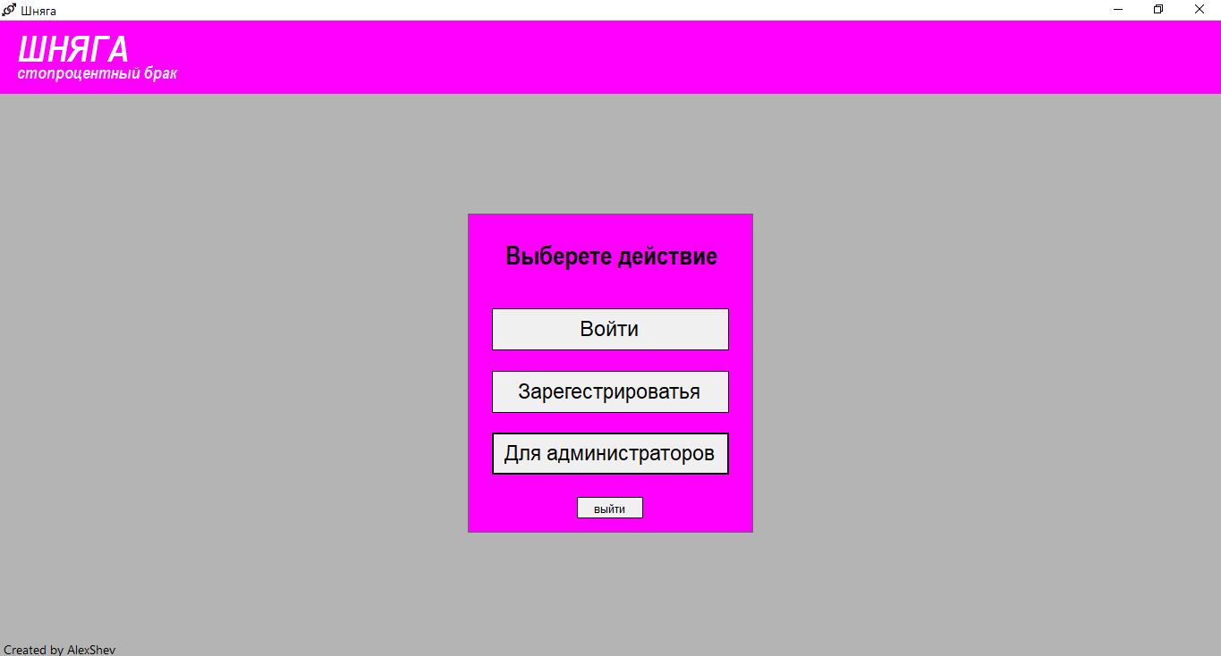

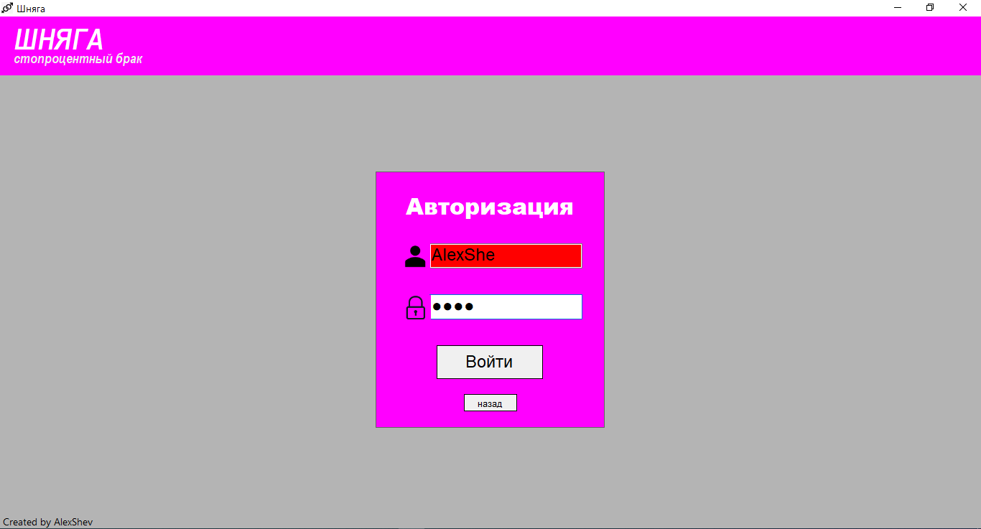

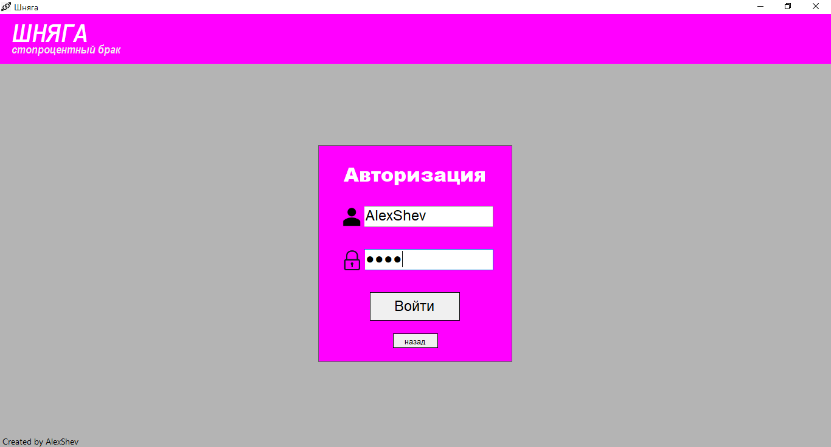

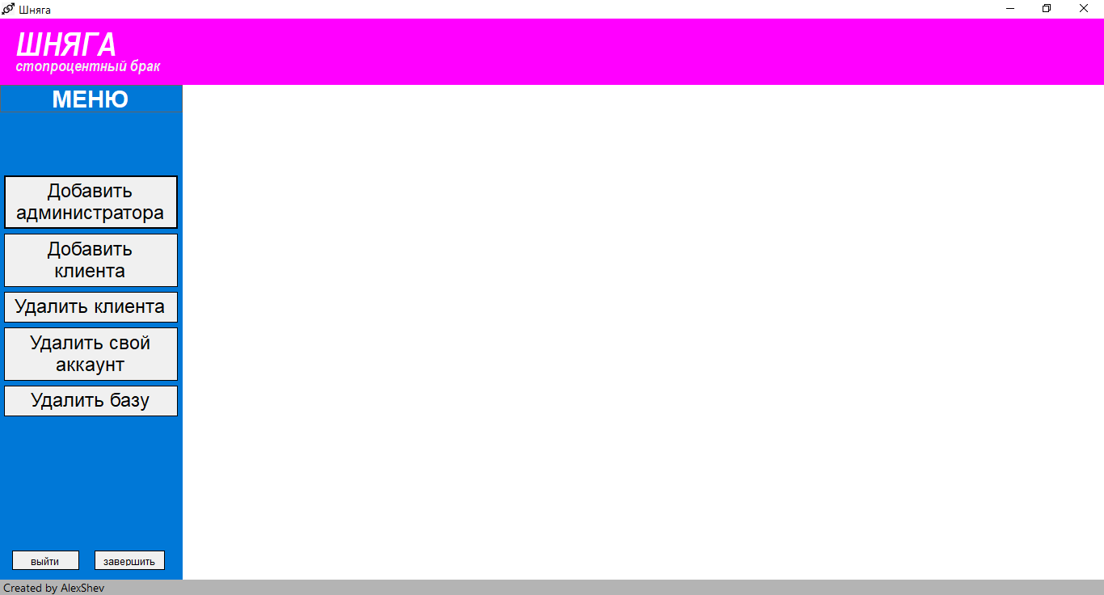

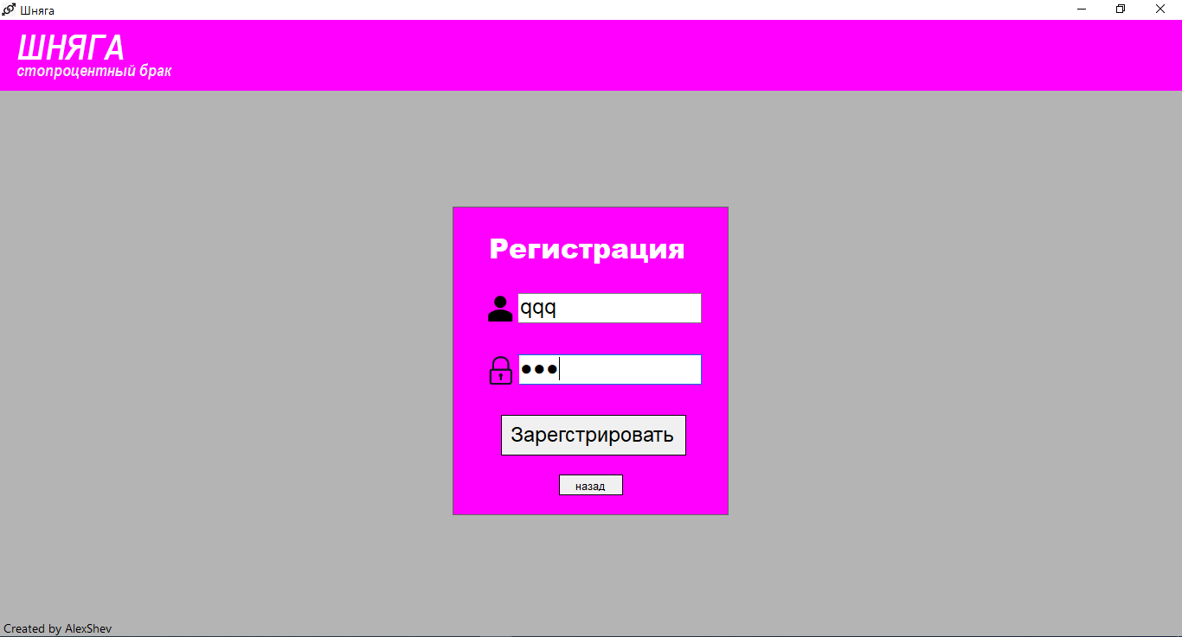

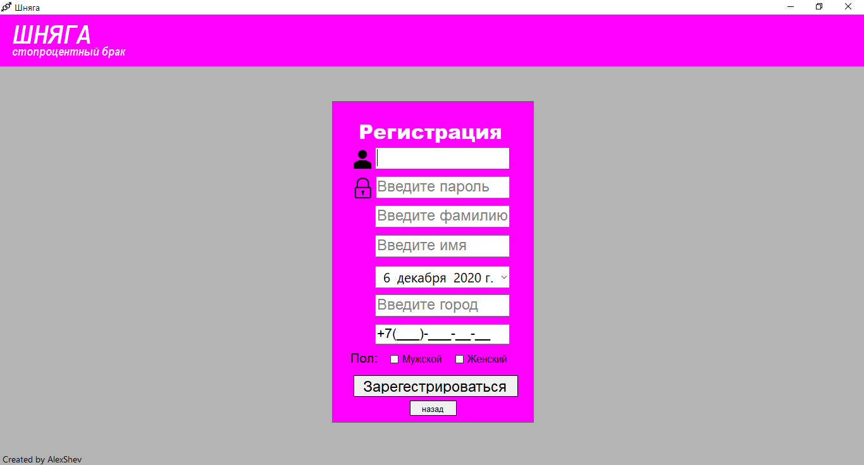

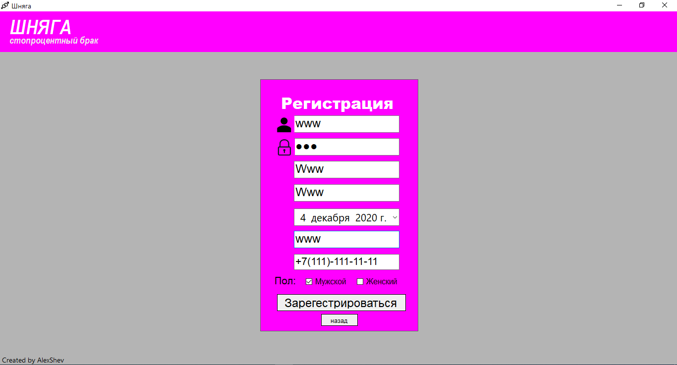

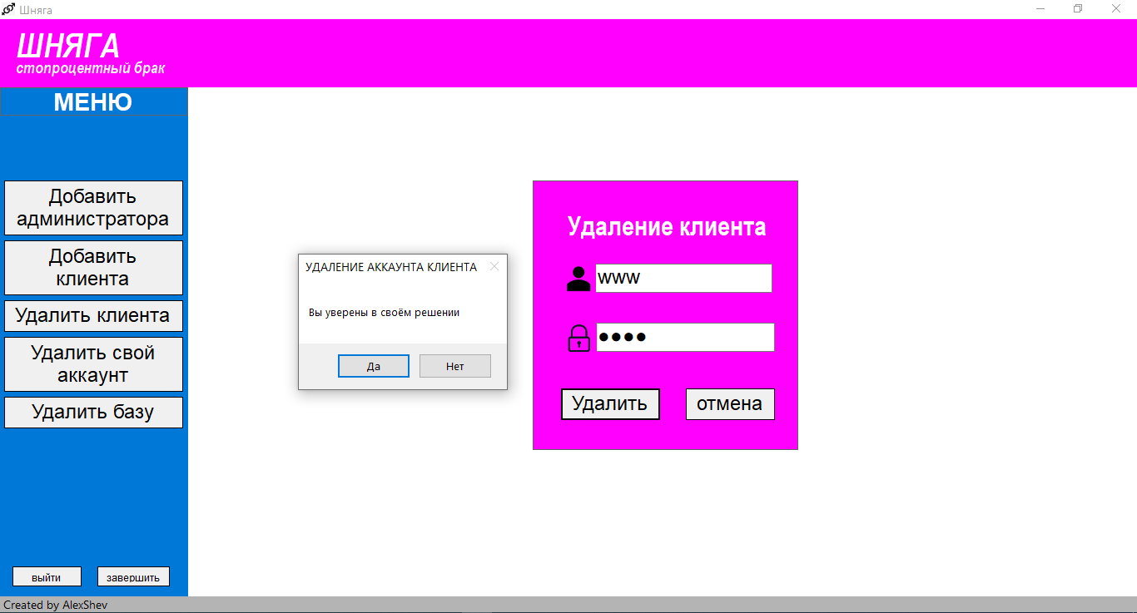

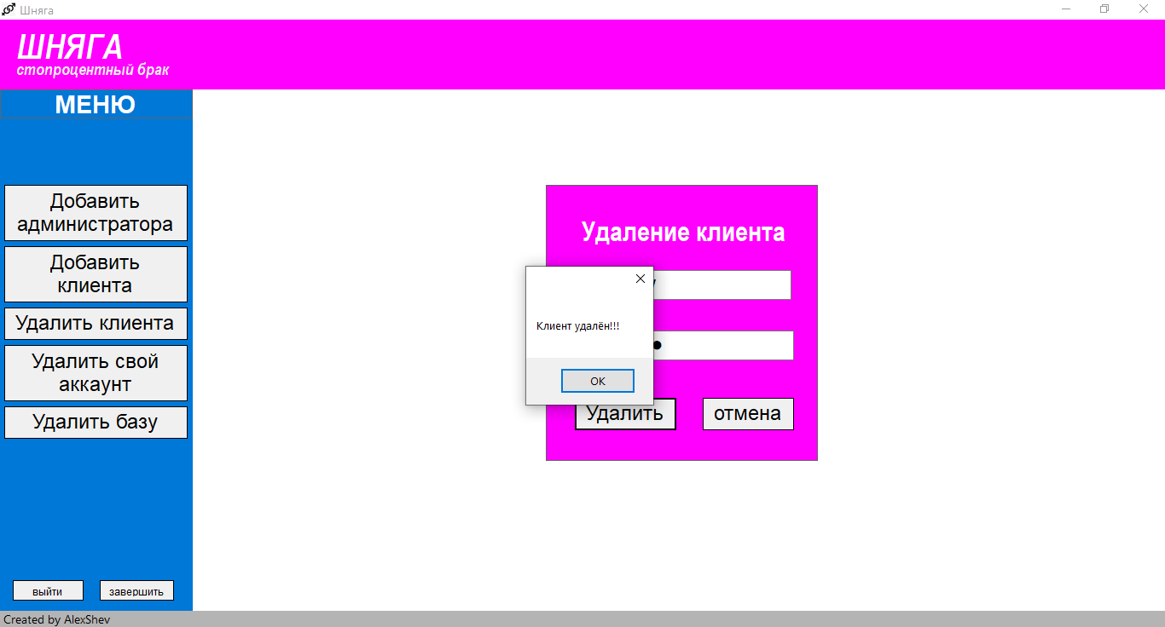

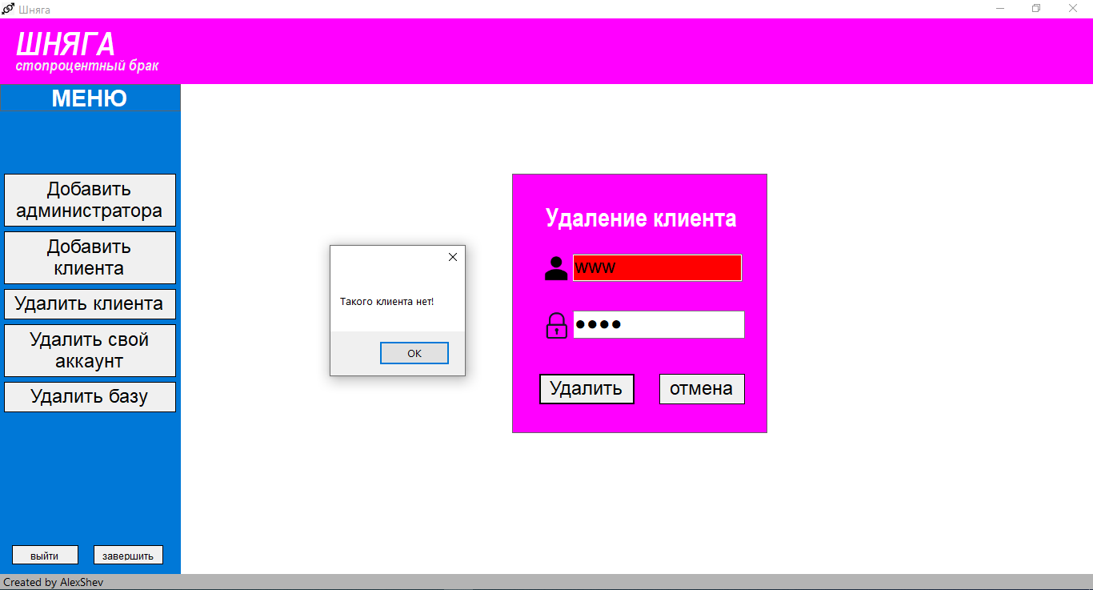

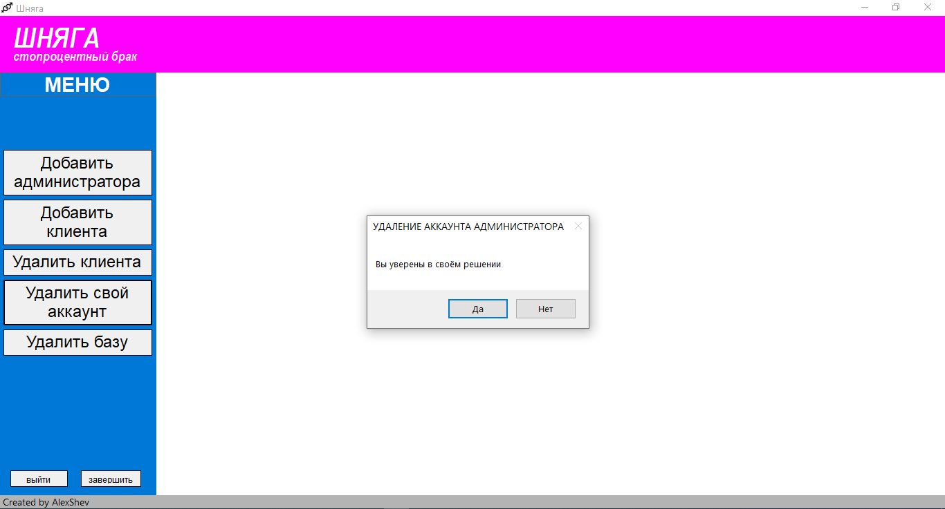

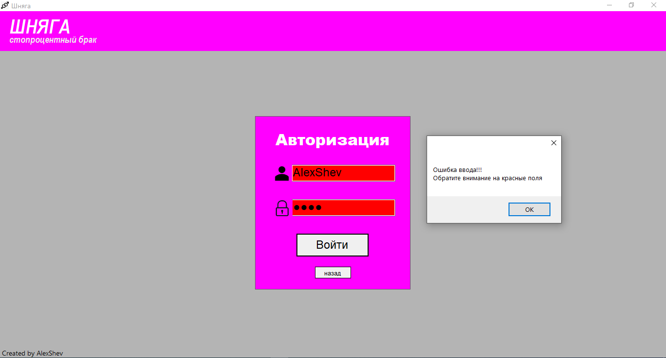

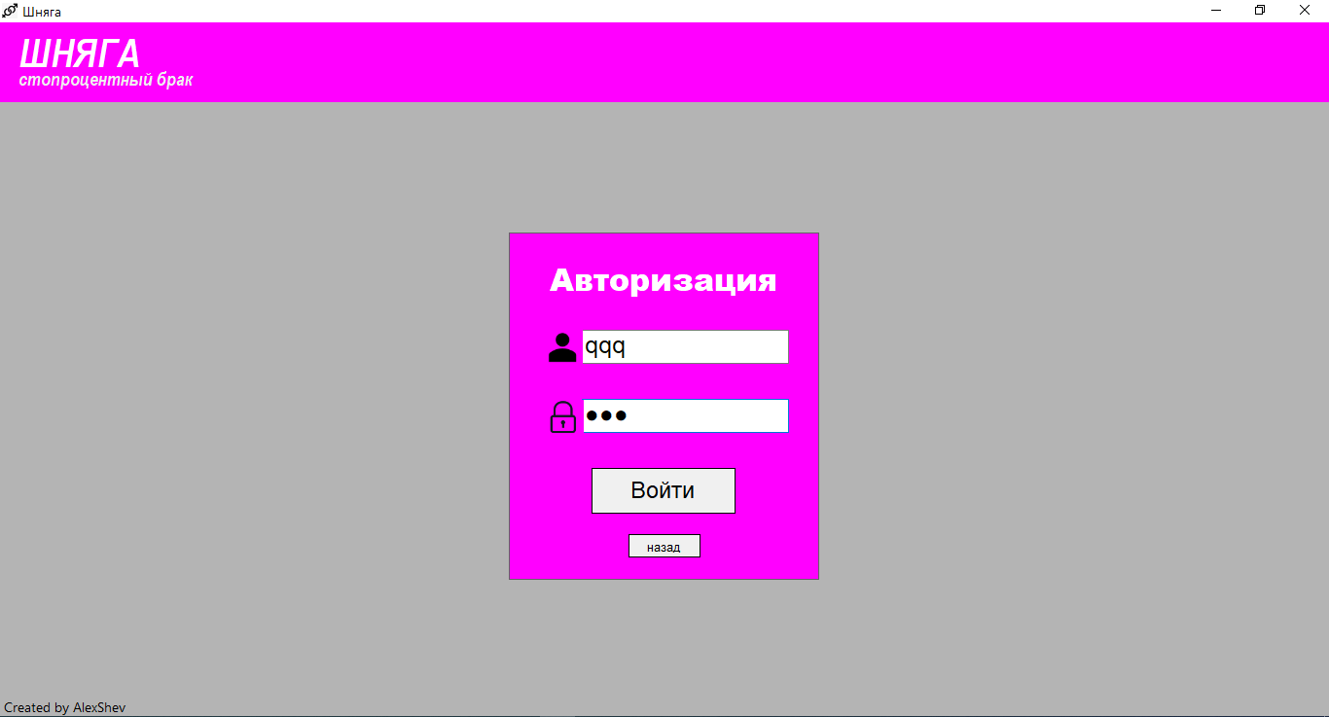

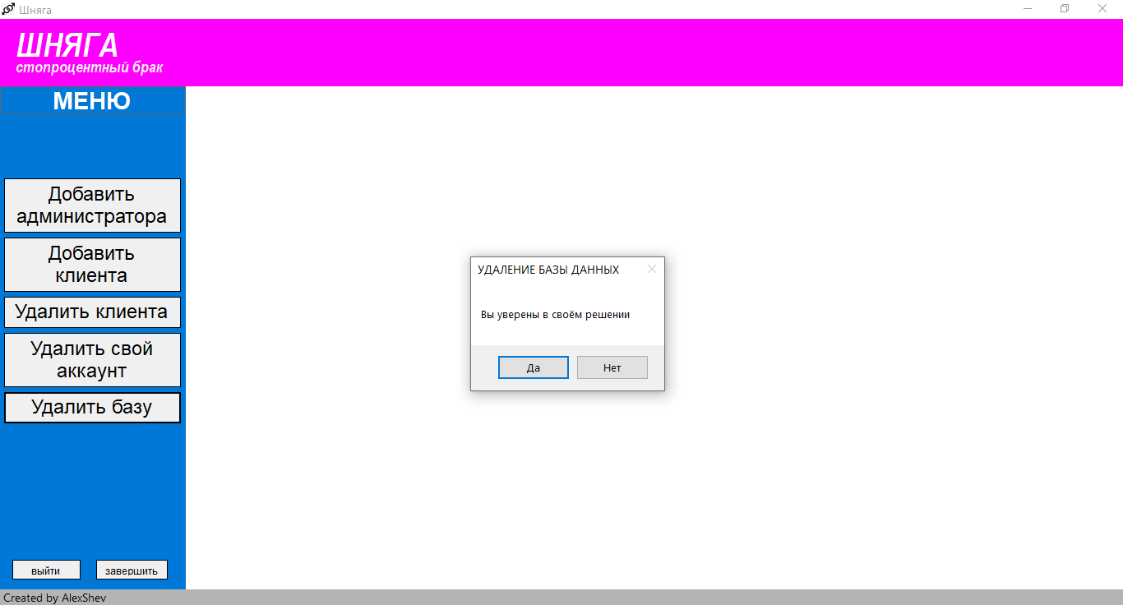

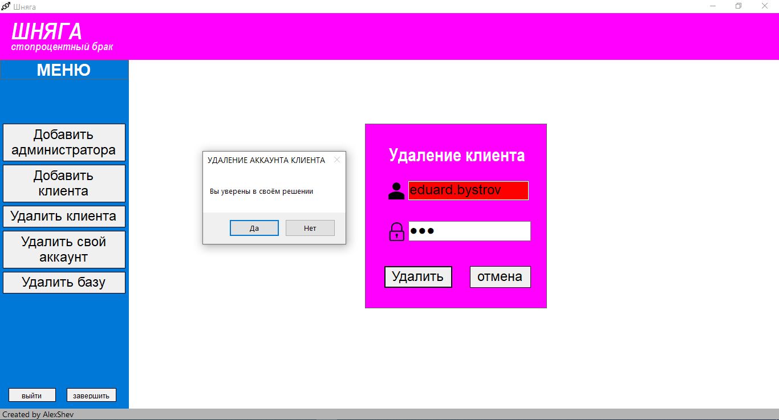

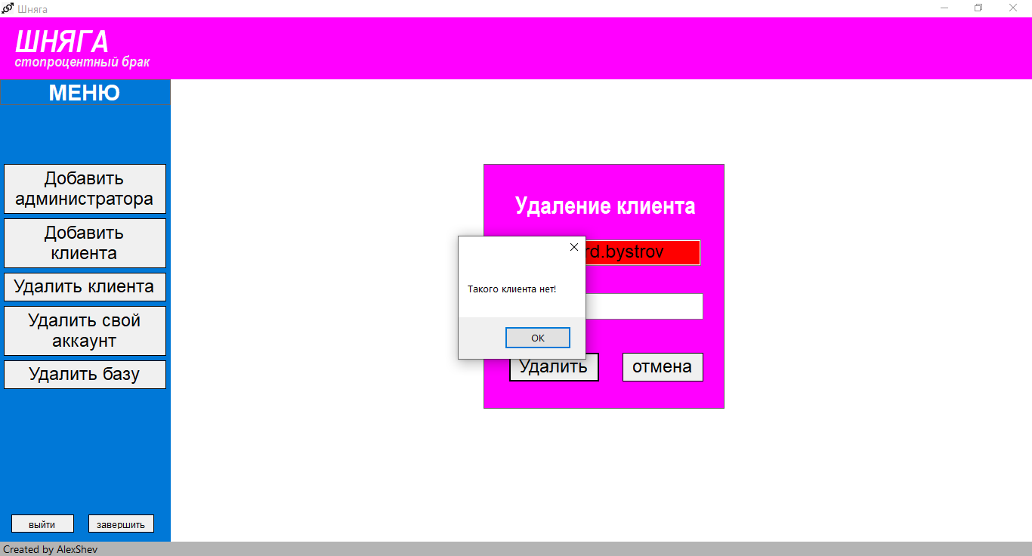

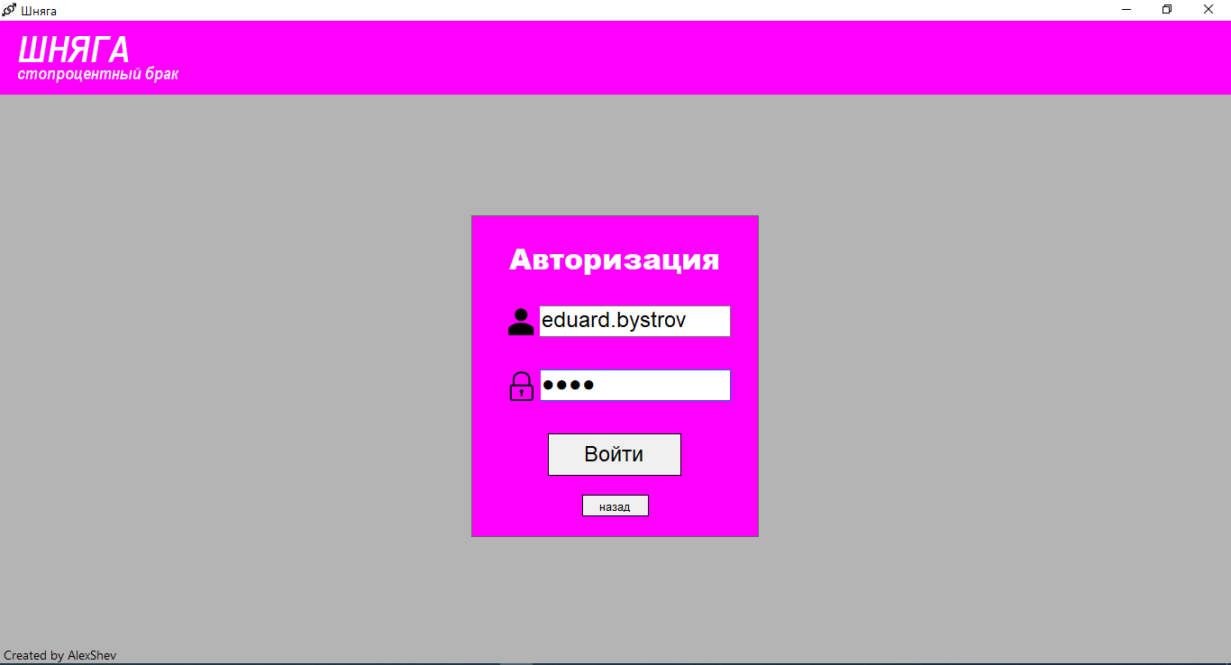

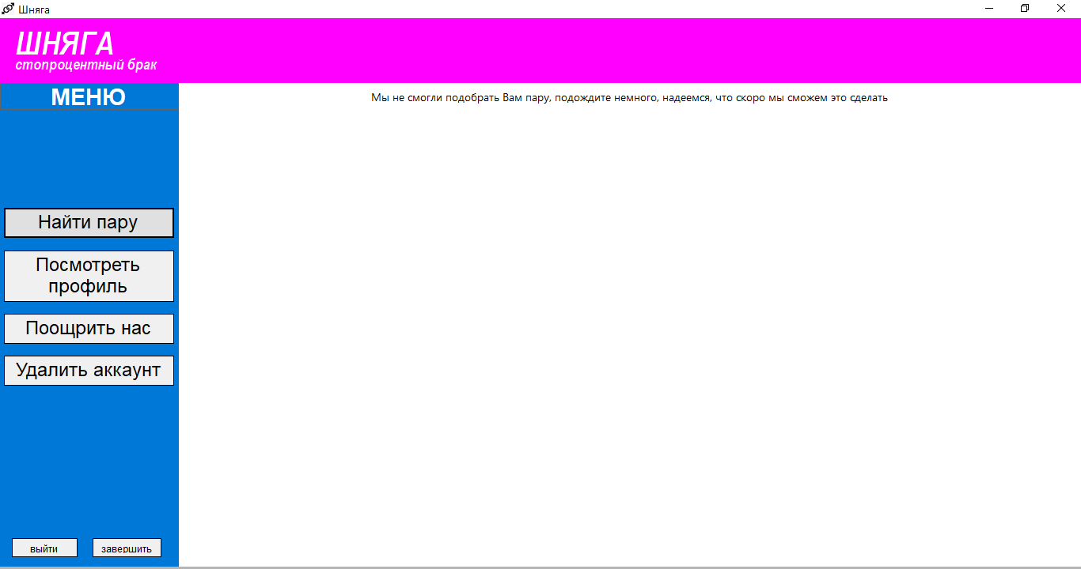

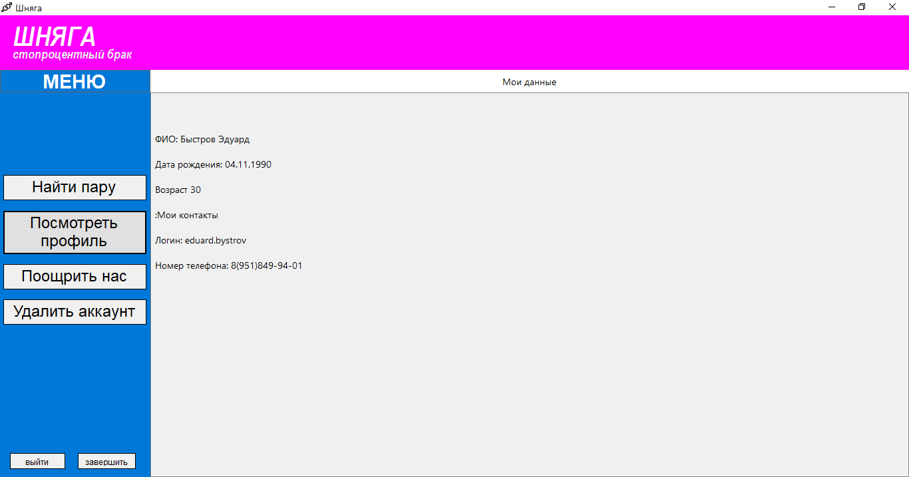

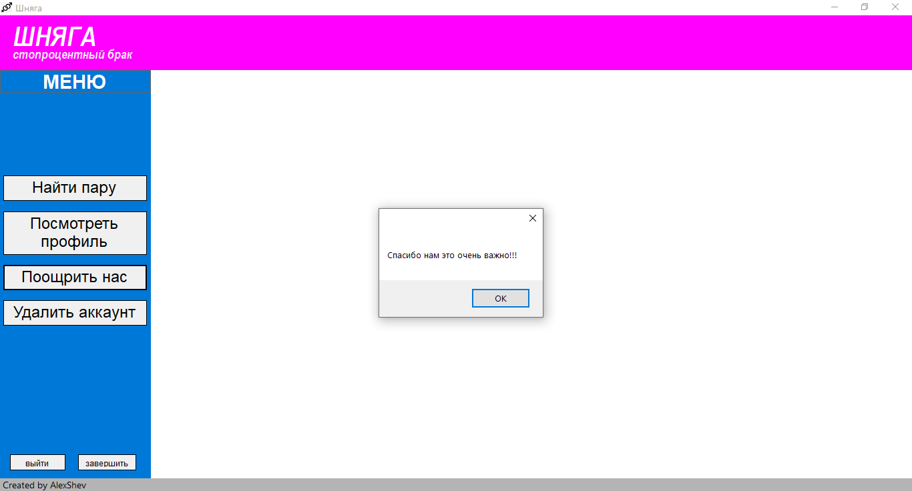

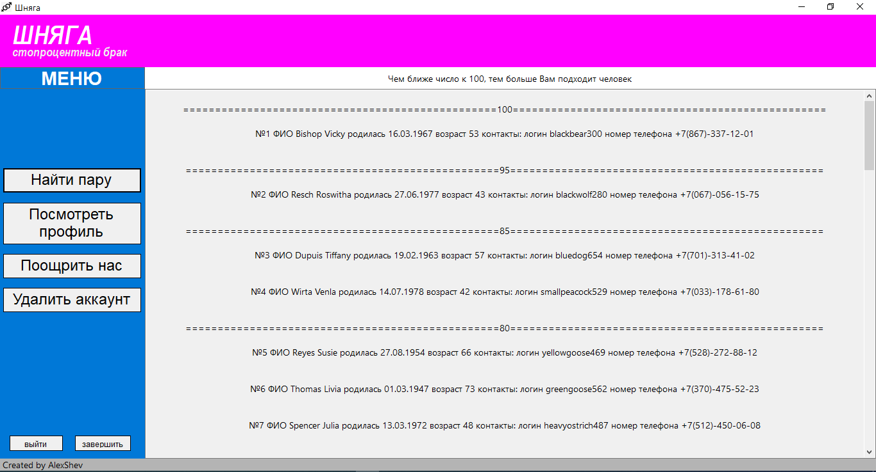

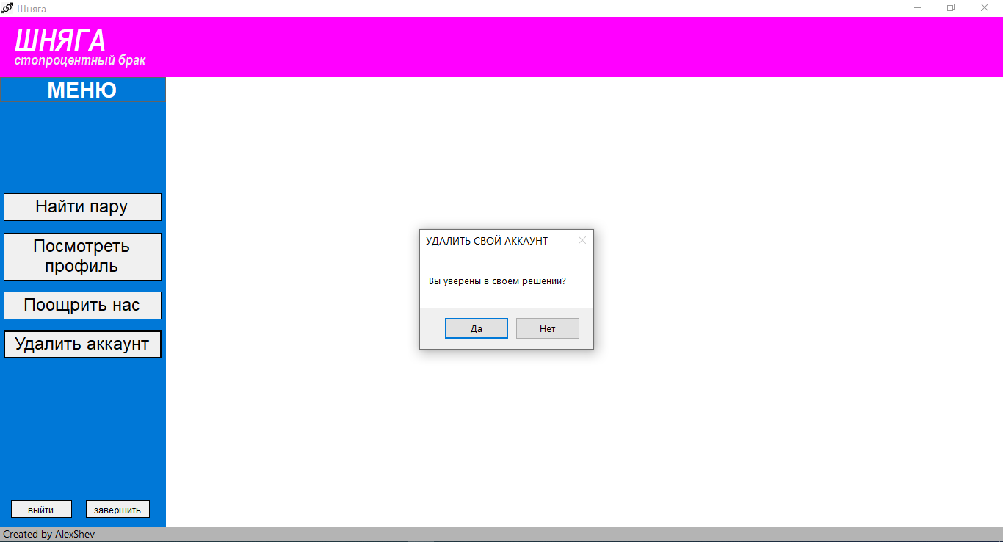

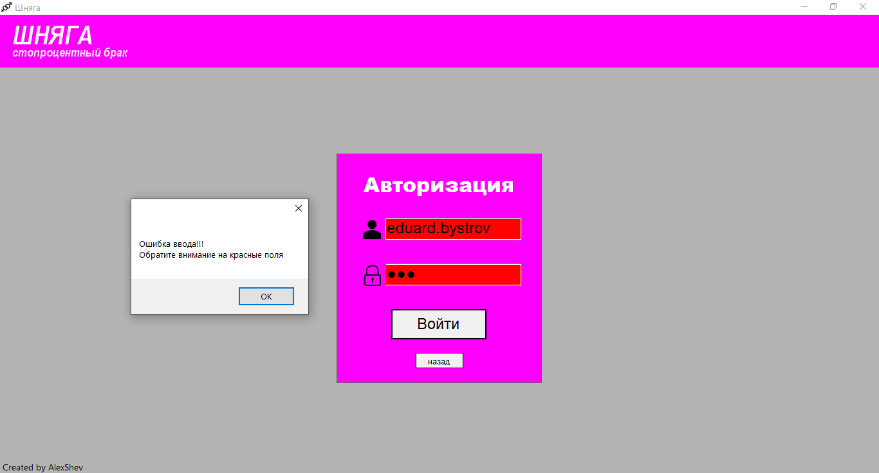

**Вывод:** был ознакомлен с основами создания графического интерфейса на С#.